Family Learning
Addition and subtraction
Y1 – addition
Concrete objects
Pictorial representation
Number lines

Y2 – addition
Bar models
Concrete objects
Column method
Making links – number bonds etc.

Y1- subtraction
Number stories (with pictures)
Number line

Y2 – subtraction
Number lines
Column method
Partitioning

Year 1 – addition
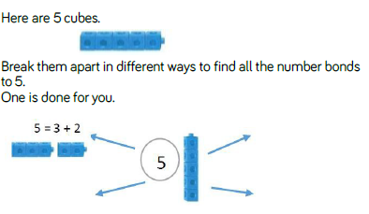

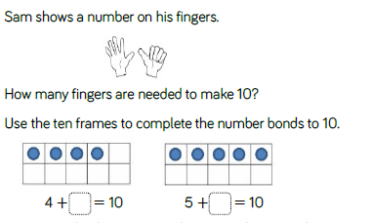
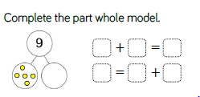

Year 2 – addition
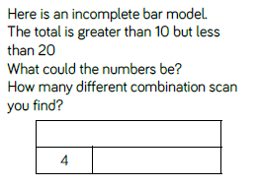

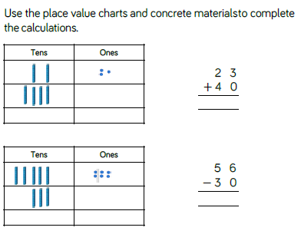
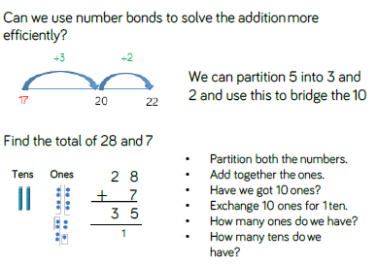

Y1 – subtraction
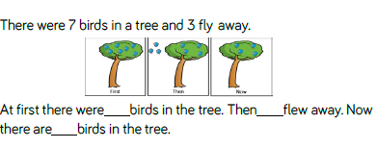
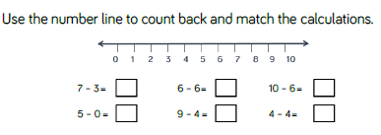

Y2 – subtraction
