Learning Project Week 11-The natural world and the rainforest.

29/06/20
Year group: 1/2
Here are suggested activities to enable you to support your child to access Maths and English learning activities at home. Open-ended activities for other subjects follow on the next pages. We would suggest Maths, Reading and Writing activities are completed daily, followed by a Learning Project activity of your choice. These are suggestions and you may wish to use resources on BBC Bitesize or other online providers. If you need any support or further challenge, please contact your child's class teacher via Class Dojo. We would love to see your Home Learning successes so please post to Class Dojo portfolios. Your work may be selected to appear in our newsletter and weekly Achievers' Collective Worship! Again, if you are having trouble with this, please message your class teacher for advice.
Maths Activities: | Year 1  https://whiterosemaths.com/homelearning/year-1/  Summer term Week 8 – (w/c 22nd June) | Year 2  https://whiterosemaths.com/homelearning/year-2/  Summer term Week 5 – (w/c 18th May) | Reading Activities
Monday- | Lesson 1 – Counting to 100 | Lesson 1 – Multiplication sentences | Monday- If you have a copy read the story of the Rumble in the jungle. If you do not have a copy listen to the story here. Discuss the story together. Which animal is your favourite? Why? Can you create a sock puppet of your favourite animal? You can retell the story with your puppet.
Tuesday- | Lesson 2 – Partitioning numbers | Lesson 2 – Arrays | Tuesday- Listen to the story Slowly, slowly, slowly said the sloth. Can you join in with the story?  Do you recognise all the animals? If not you could you research them and find out all about them.
Wednesday | Lesson 3 –Comparing numbers 1 | Lesson 3 – 2 times tables | Wednesday- Visit RSPB website for some stories set in nature. There are some to read and some audio ones to listen to. Which one do you like the most?
Thursday- | Lesson 4 – Comparing numbers 2 | Lesson 4 – 5 times tables | Thursday- Listen to the story of the Cacao tree. What have you learnt about where chocolate comes from? Create a poster about the cacao tree or follow a recipe that includes chocolate as an ingredient.
Friday- | Maths challenge: Year 1 & Year 2: Make a tally chart for 5-10 creatures or plants you think you will find in the garden. For example: ants, nettles, daisies, spiders etc. Go on a hunt in the back garden and collect your data using the tally chart. Which creature or plant was most popular? Least popular? Can you make a bar chart to show your results? |  | Friday- Do you have a favourite animal story?  Take it outside and read in the sunshine. How does it feel to be outside with a book?
Spellings Activities |  |  | Writing Activities
Monday- The word ‘rain’ contains the sound ‘ai ’. Ask your child to list as many words as they can containing the ‘ai’ sound. Your child might identify words that contain an alternative spelling for ‘ai ’ such as ay / a-e. |  |  | Monday- Your child could start a nature diary. At the same time each day, they could record the animals that they can see in the garden or from their window and describe the weather and plants. What differences do they notice over the week? Or a month?
Tuesday- Visit Phonics play and explore the different games.  The site is free for parents to use at the moment. |  |  | Tuesday- Imagine you are in the rainforest. What can you see? Hear? Smell? Touch? Taste?  Write a description about being in the rainforest and what you think it would be like.  Use this link to hear some sounds of the rainforest.
Wednesday- A-Z challenge – can you think of an animal or plant that begins with each letter of the alphabet? Could you do one about the rainforest? What about one for the animals and plants near your house? |  |  | Wednesday- Visit BBC class clips to see some amazing nature videos. Use one of these as inspiration to write a story. For example; watch the polar bear video and write a story about a Mum and her cubs playing in the snow.
Thursday- Can you explore the suffix –ment? Think about the rule when adding the suffix to a root word. When adding –ment it changes a verb into a noun.  Practice adding –ment to the following words and check your spelling.  enjoy, amuse, employ, excite, agree, pay, move and equip.  Can you write a sentence with the new word? |  |  | Thursday- Visit the literacy shed to watch this video Caterpillar shoes.  There is a pack of ideas and activities related to the video. You could write a thank you letter as one of the insects to the caterpillar thanking him for the shoes.
Friday- The tree frog, spider monkey and boa constrictor are just some of the animals that can be found living in a rainforest. Ask your child to list verbs (action words) to describe how each animal moves. How many can they think of? |  |  | Friday- Can your child create a fact file about a spider monkey or a tree frog? Describe the animal’s appearance, habitat, diet and any other facts.
Learning Project - to be done throughout the week
The project this week aims to provide opportunities for your child to learn more about the natural world and the rainforests. Learning may focus on art based on the natural world and learning more about the plants, animals and insects that inhabit the rainforest.
Where in the world are rainforests?
Using an atlas or online map, can your child locate the continents (Africa, Asia, Australia, Central America and South America) where rainforests can be found? If this is too challenging, can your child locate one country with a rainforest, and then locate the UK. Ask them to describe the similarities and differences between the UK and the country they have located.
Land art:
Based on David Goldsworthy’s Land Art, pupils are to create their own piece of art, with the focus on SHAPE.

Watch this video.
Pupils collects a variety of items from nature. Think about the composition when collecting items, focusing on shape and patterns.
Remember to take a photo of it when it is complete.
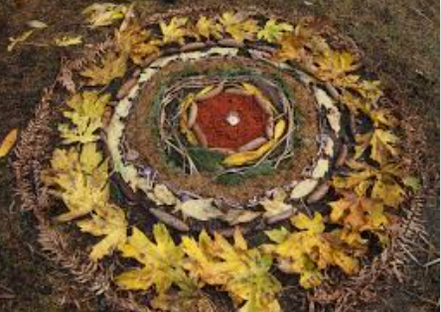
Creating a collage landscape:
Watch this video on how to create a collage using various materials.
Children to create their own collage of the landscape outside. Take a photo of the landscape if it is raining to use as reference.
Make a picture that can be explored by touch and hearing as well as sight.

Experiment with different textures, man-made and natural, to create specific effects.

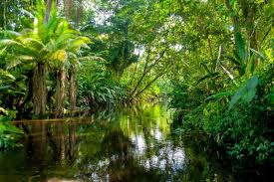

Explore colour:
Go on a colour walk and find as many different coloured objects, plants and creatures as you can. Record in a box like this.
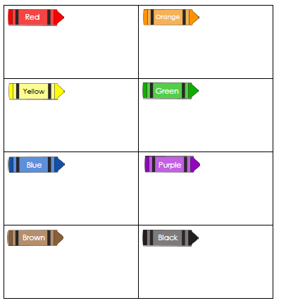

Leaf printing:
Children to collect leaves and to use paint to cover them and make leaf print pictures.
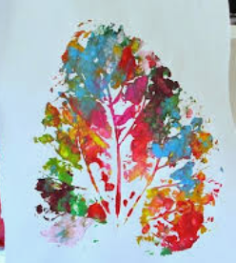

Get creative!
Can your child create a detailed sketch of an animal that inhabits the rainforest?
Using pencils, crayons or whatever else you have, ask your child to copy an image of a rainforest animal, thinking carefully about the patterns and tones.

STEM Learning Opportunities
Rainforest insects
● Watch this video about the rainforest and find information here about insects. Look for mini-beasts living in the garden or on a walk. What are these mini beasts called? Which one do you like the best and why? Try drawing pictures of the mini-beasts you find.

Internet Safety Activities
The following links are intended to provide you with support and resources to help you learn about online safety at home with your child.
- https://www.thinkuknow.co.uk/parents/support-tools/home-activity-worksheets/
- Go to website for week 5 of the Think you know online safety at home learning pack. You will be linked to a series of videos called Jessie and Friends which are age appropriate animations that deal with online safety issues.
- This week you will read a storybook together and design your own superhero.
- https://www.childnet.com/resources/online-safety-activities-you-can-do-from-home

Additional learning resources
- BBC Bitesize-Lots of videos and learning opportunities for all subjects
- Classroom Secrets Learning Packs-Reading, writing and maths activities for different ages.
TT Rockstars/Monster Multiplication-Your child can access both of these programmes with their school logins. On Times Table Rockstars, children should aim to play Soundcheck for 10 minutes daily.
- IXL online. Click here for Year 1 or here for Year 2. There are interactive games to play and guides for parents

https://www.mathematicsmastery.org/free-resources. Take a look at the mastery mathematics home learning packs with a range of different activities and lessons
- Year 2 Talk for writing project and Year 1 are an excellent resource to support your child’s speaking and listening, reading and writing skills.

The Learning Projects are based on the National Curriculum expectations for the key stage which your child is in. If your child requires more of a challenge, or you believe that there are some gaps in their learning then Century Tech is a fantastic resource that is currently free for home learning. The app is designed to address gaps and misconceptions, provide challenge and enables children to retain new knowledge. It uses artificial intelligence to tailor the learning to your child’s needs. Sign up here.

