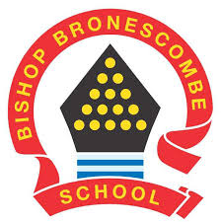
Learning Project WEEK 4- VE day celebrations

Year group: 1/2
Suggested Maths Activities  for Week 4 | Suggested Reading Activities  for Week 4
- Fact families: Give your child a calculation i.e. 12 + 14 = 26 and get them to write the fact family for this calculation. A fact family has two additions and two subtractions; so the fact family for this calculation would be:  12 +14 = 26 14 + 12 = 26  26 – 12 = 14 26 – 14 = 12 | - This week, we will thinking about how people in Britain will be celebrating VE Day on Friday 8th May. Read the fact files about VE Day and how it is celebrated in Britain. (See separate file named ‘VE Day Resources) Write down any new words and their meaning.
- Order the days of the week and the months of the year. Practice saying these in order. You could quiz your child and ask “Which month comes after July? Which day comes before Sunday?”  You could play this game to help with this. | - Read one of your home reading books and write or retell your own an alternative ending. You may want to do this by creating puppets, drawing pictures or acting it out for your family.
- Measuring height and length: get your child to find items around the house and measure their length/height in cms, get them to order the objects from shortest to longest.
Challenge for Year 2s: Find the difference in length/height between some of your objects.
You can practise your measuring skills with this game: measuring in cms

Suggested Spelling/Grammar Activities  for Week 4 | Suggested Writing Activities  for Week 4
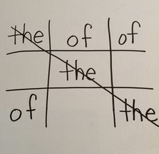  - Revisit the list of spellings for the common exception words for year one and two. Identify which of these spellings your child is not securely spelling accurately yet and play tic tac toe to help them practise spelling some of these words accurately. | 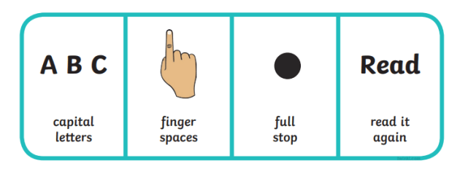  - Using what you’ve learnt through researching VE Day and how it was celebrated, write down as many interesting facts as you can to teach someone else. Before you write your facts, you may want to make a list of the things your writing will need to include!
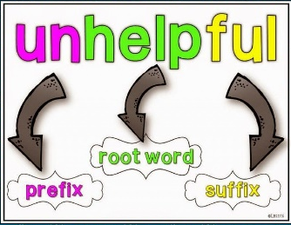  - Use books, magazines or online stories this week and challenge yourself to spot as many words as you can with different prefixes and suffixes! | - How many sentences you can create using the words and phrases in the table below. Don’t forget to use capital letters and the correct punctuation in each sentence. You could challenge yourself to use adverbs and adjectives in each sentence!  8th May remember parties country  Friday soldiers announce bravery  Britain VE Day celebrate Second World War  Winston Churchill flags surrender Germany
Learning Project - to be done throughout the week
On Friday 8 May, Britain will be commemorating the 75th anniversary of VE Day when the guns fell silent at the end of war in Europe. This week’s learning project is the same for the whole school and provides children with the opportunity to explore rationing and wartime recipes, delve deeper into the main front line fighter during WW2, conduct research into wartime music, consider what life would have been like for a survivor of the war and even the opportunity to host their very own VE Day party. Please see the website for the suggested activities.
Wartime Recipes
During the 1940s and 50s, food was rationed so only certain foods were available to buy. Follow the link below and have a go at creating one of your very own wartime recipes.
https://the1940sexperiment.com/100-wartime-recipes/

Design a British medal
Your task is to create a medal for British soldiers who served in the Second World War. Your medal can be any shape or size but you must have considered the metal and ribbon choices.
You must include:
- The years of the war ( 1939-45)
- The colours of the Allies
- A symbol to signify the war and the soldier’s sacrifice and victory.
- A reference to the many theatres of the fighting ( Europe, Africa, Asia, Sea, Land)
- Annotations to explain your choices.

Wartime Music
Why not listen to some wartime songs (links for a couple are below). Which one was your favourite? What instruments could you hear? How did it make you feel?
We'll meet again
The White Cliffs of Dover
You might like to create a piece of art work around your favourite song or even have a go at creating and performing your very own wartime song.

Design and make your very own Spitfire
Why not research Spitfires and then either choose your favourite or create your very own design? There is a template on the school website if you have access to a printer at home.

Great British Bunting
On Friday 8 May, Britain will be commemorating the 75th anniversary of VE Day when the guns fell silent at the end of war in Europe. Due to the coronavirus restrictions, most VE Day 75 events and street parties have had to be cancelled or postponed but we still want you to be able to mark the occasion, share your pride in our country and honour the men and women of WW2.
You can make your own special VE Day 75 ‘Great British Bunting’ to display in your window at home. Follow the link below with all of the instructions you need to get started using any paper, cereal boxes, string, ribbon, sweet wrappers, felt pens, poster paint you have or whatever you can find.
You can decorate your bunting with pictures of whatever inspires you, whether it’s those who fought on the frontline or worked hard on the Homefront, or whether it’s a celebration of enduring peace or your own personal hero. Hang your bunting with pride over the weekend of Friday 8 May - Sunday 10 May and make sure you share your pictures with us.
https://www.bbc.co.uk/programmes/articles/4TrqYDyf4PMdLypxzyTwGDg/great-british-bunting

VE Street Party
Your task is to pretend that you helped to organise this street party. Can you write a list of all of the things that would be needed for the party?
You might want to create an invitation to the party (pretending that it is on your street), try to make sure you have the right date!

