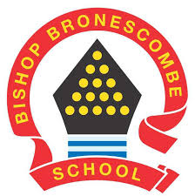
Learning Project WEEK 9 – Under the sea

Year group: 1/2
Suggested Maths Activities  for Week 9 | Suggested Reading Activities  for Week 9
We wanted to make use of a brilliant online resource from white rose, so we will be adding links to these lessons. We also wanted to provide suggestions for practical activities based around these lessons for those families who want to limit screen time during home learning.  (Please be aware that the dates will not coincide with White rose dates, as we haven’t been using this resource since the start of lockdown ) | - If you have it, read ‘The snail and the whale’, if you don’t have it, watch this link to watch it being read. Discuss where they would like to go and visit if they could travel across the ocean.
Year 1
https://whiterosemaths.com/homelearning/year-1/  Suggested lessons:  Summer term Week 7 – (w/c 8th June)  Lesson 1 – Count in 2s.  Lesson 2 – Count in 5s.  Lesson 3 – Count in 10s.  Lesson 4 – Add equal groups.  The worksheets for these sessions will be made available on dojo.  Practical suggestions:  - Get your child to show you how we do counting in 2s, 5s and 10s in school using actions to help use  - Collect pieces of lego, pegs, counters (whatever you have a lot of at home), put them in groups of 2s, 5s and 10s to build up confidence with counting in these multiples  - Using the resources, ask your child to make set groups i.e. 3 groups of 5, 6 groups of 2, get your child to make the groups and then find out the answer and then write it as a repeated addition i.e. 3 groups of 5 would be 5 + 5 + 5 = 15 | - Listen to story - A hole at the bottom of the sea.  - Can your child draw a picture of their favourite part of the story?  - Extension: create their own version of the story.
- Encourage your child to learn the rhyme – A sailor went to sea, sea, sea.
- Click here for a version of the song.
- Can they learn the rhyme by heart?

Year 2
https://whiterosemaths.com/homelearning/year-2/
Suggested lessons:
Summer term Week 3 – (w/c 4th May
Lesson 1 – Fact families addition and subtraction bonds to 20.
Lesson 2 – Compare number sentences
Lesson 3 – Related facts
Lesson 4 – Add and subtract 1s
The worksheets for these sessions will be made available on dojo.
Practical suggestions:
- Practice number bonds to 20 and show this using objects.
- Practice recall of number bonds to 10 and 100. Play ping pong where someone says a number e.g. 6 and next partner says how many more to make 10.
- Use objects to support adding and subtracting in 1s.
Suggested Spelling/Grammar Activities  for Week 9 | Suggested Writing Activities  for Week 9
- Go on a sound hunt with your child around the house/garden. They can list all of the items they can find containing the ‘ ea ’ sound. They may identify objects that contain an alternative way of spelling the ‘ ea ’ sound such as ee / y / e. | - Imagine you are stuck on a desert island. How did you get here? What does it feel like? You are going to write a message in a bottle to explain what you can see, hear, feel, touch and taste.
- Visit Phonics play and explore the different games.  - The site is free for parents to use at the moment. | - Create a fact file about your favourite undersea creature. Remember to include information about: - what it looks like  - what it eats  - what ocean it lives in or the part it lives in
- Make a list of words that you think of when thinking about the sea. Can you think of rhyming words to match them?
- E.g. fish and dish.
- Can you make a list of words for the following spelling rules?  Rule 1: The ‘l’ sound can be spelt ‘al’ at the end of words (i.e. metal).  Rule 2: The long ‘I’ sound is spelt ‘y’ at the end of words (i.e. cry, fly).  Rule 3: The ‘or’ sound is usually spelt using an ‘a’ before l or ll (i.e. wall, talk). | - Visit the literacy shed to watch this video The Lighthouse  - There is an activity pack full of different writing ideas.  - Please watch the video first without your child to check you are happy with it. The video involves a ship heading towards the rocks when the light breaks in the lighthouse. The ship is saved.  - Alternatively create a beach safety poster about how to keep safe when visiting the beach.
Online safety at home
for Week 9
- Go to web page for week 2 of the Think you know online safety at home learning pack.
- You will be linked to a series of videos called Jessie and Friends which are age appropriate animations that deal with online safety issues.
- This week you will share the storybook about sharing pictures and learn the funny tummy song. Go to the bottom of the page where videos are to find the link for storybooks.

Learning Project - to be done throughout the week
The project this week aims to provide opportunities for your child to learn more about life in and around the sea. Learning may focus on the strange and wonderful creatures and plants that occupy our oceans, their habitats and how human beings travel on the ocean.
Oceans of the world
Look at a globe or map and explore the different oceans. Can you name all the major oceans?
Explore the ocean:
Click here to see a live stream of a tropical reef or here for sharks in the Atlantic. While watching can they sketch some of the animals they see and discuss the colours and patterns they can see.

Get creative!
Junk modelling.
Can your child build their own sea turtle? Use junk or recycled materials to create your creature.
Make sure you decorate it and send a photo to your teacher.

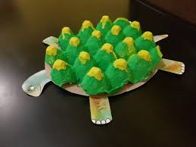

Lifecycles:
Research the lifecycle of a sea turtle. Can they create a poster to show the different life stages?

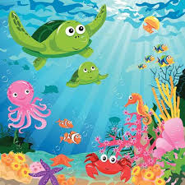
Ocean in a bottle:
Make your very own ocean in a bottle following these instructions.

STEM challenge
Discuss boats and what they are made from. How do boats float? Design, make and test their own boat. Investigate the different ways humans can travel on or in the ocean.
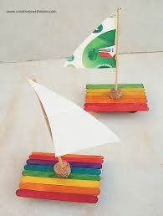

Music
Teach your child the song Under the sea from the Little Mermaid.
Additional learning resources you may want to engage with:
Classroom secrets learning packs: https://classroomsecrets.co.uk/free-home-learning-packs/
BBC Bitesize daily lessons: https://www.bbc.co.uk/bitesize/dailylessons

