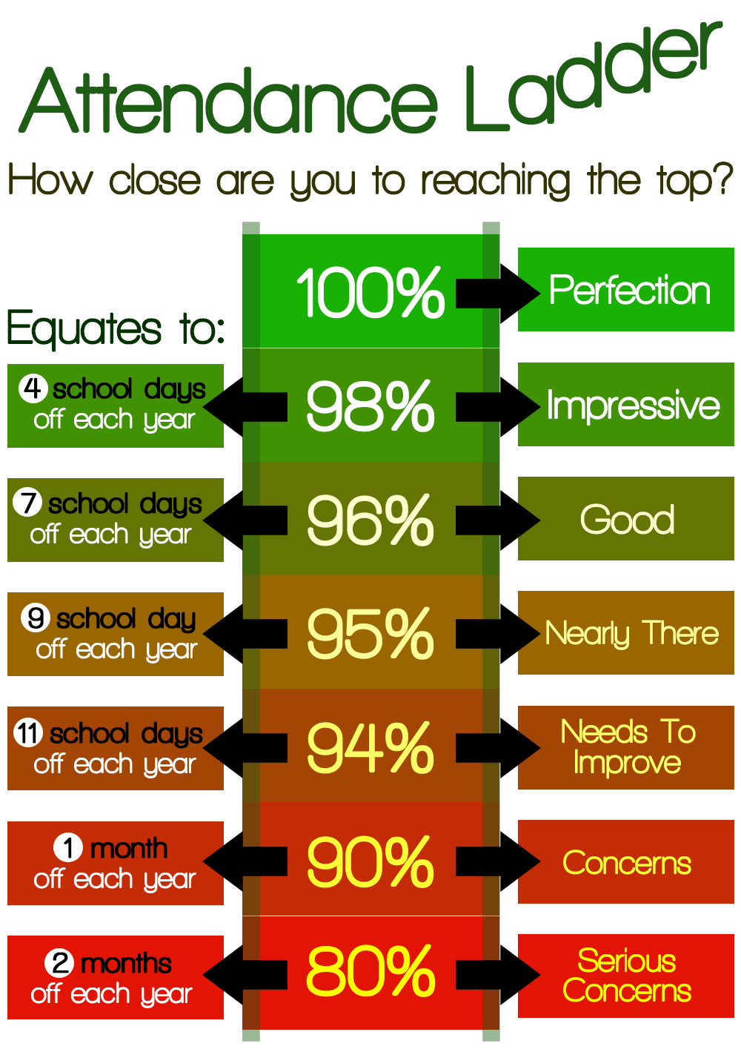
Do you know all about our attendance ladder and where your child sits?
We can work together, if everyone commits!
Our school has high expectations for everyone to reach the top,
Statistics are monitored weekly to ensure progress doesn’t stop!

Our PSA is tasked with supporting those who ‘down the ladder fall’,
You may receive a letter or an email or to begin with just a friendly call.
Any child who sits above 96% is comfortably in the clear;
Those below are monitored; the stats reflect the whole school year.

Those children on 95% are so very nearly ‘there’;
The school has to have a target; it’s the way we show that we care!
11 days off each school year, puts your child at 94 percent,
Improvement is required to counteract the ‘ladder-descent’.

We have a rated system to alert parents to the statistics;
At AMBER we need to be talking through any issues and logistics.
A child at 90-93% gives schools reasons to be concerned;
We know that this will impact on the things a child can learn.

For those whose percentage falls below 90, the RED band is alerted,
We’d really like to support you so that a crisis can be averted.
90% attendance equates to one whole month off each school year,
This substantially will impact on your child in comparison to their peers.

Your PSA is available; she can update you on your figures;
You can call or drop her an email or simply nip in to see her!
She’s friendly and approachable, and really wants to work with you,
So many things affect attendance; she’ll support you with any issue.

