Learning Project Week 13-Around the World

13/07/20
Year group: 1/2
Here are suggested activities to enable you to support your child to access Maths and English learning activities at home. Open-ended activities for other subjects follow on the next pages. We would suggest Maths, Reading and Writing activities are completed daily, followed by a Learning Project activity of your choice. These are suggestions and you may wish to use resources on BBC Bitesize or other online providers. If you need any support or further challenge, please contact your child's class teacher via Class Dojo. We would love to see your Home Learning successes so please post to Class Dojo portfolios. Your work may be selected to appear in our newsletter and weekly Achievers' Collective Worship! Again, if you are having trouble with this, please message your class teacher for advice.
Maths Activities: | Year 1  https://whiterosemaths.com/homelearning/year-1/  Summer term Week 12 – (w/c 17th July) | Year 2  https://whiterosemaths.com/homelearning/year-2/  Summer term Week 8 – (w/c 15th June) | Reading Activities
Monday- | Lesson 1 – Time to the hour. | Lesson 1 – Count sides and vertices on 2D shapes. | Monday- Listen to the story Here we are by Oliver Jeffers. Discuss what makes our world so special. Can you make a list of reasons?
Tuesday- | Lesson 2 – Time to the half hour. | Lesson 2 – Count faces, edges and vertices on 3D shapes. | Tuesday- Use an atlas or a map and locate countries that make up the UK. Your child can then locate a contrasting country such as Brazil or Kenya. What is different? What is the same? Use this website to help you.
Wednesday | Lesson 3 – Writing time | Lesson 3 – Sorting 2D and 3D shapes. | Wednesday- Listen to the story When I coloured in the world. What would you change about the world? Draw a picture to show your changes.
Thursday- | Lesson 4 – Comparing time | Lesson 4 – Patterns with 2D and 3D shapes. | Thursday- Explore the National Geographic website here. Choose a country or place to read about and find out some interesting facts.
Friday- | Maths challenge: Make your own clock and practice telling the time. Can you read o’clock times? Half past times? Quarter past and quarter to? If you are really good you could practice telling the time to the nearest five minutes. 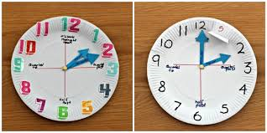 |  | Friday- Listen to a group of stories from around the world here. Which one is your favourite? Why? Draw a picture or a comic strip of your favourite one.
Spellings Activities |  |  | Writing Activities
Monday- The word ‘around’ contains the sound ‘ou’. Ask your child to list as many words as they can containing the ‘ou’ sound. Your child might identify words that contain an alternative spelling for ‘ou’ such as ow. |  |  | Monday- Draw a picture of 10 different pieces of fruit or vegetables from around the world and label them using adjectives e.g. fresh, juicy pineapple.
Tuesday- Visit Phonics play and explore the different games.  The site is free for parents to use at the moment. |  |  | Tuesday- Barnaby bear is travelling the world. See this website to see him on his travels. Explore the different places he goes and find a place that interests you. Write a postcard home pretending you are there. Make sure to include information about what you have seen.
Wednesday- ‘Where’, ‘would’, ‘people’, ‘clothes’ and ‘water’ are some of the words that children in KS1 need to be able to spell. Can your child use these to write sentences about a contrasting country? |  |  | Wednesday- Write your own version of the story When I coloured the world. You could make it into a book with your own illustrations.
Thursday- Can you explore the suffix -ful? Think about the rule when adding the suffix to a root word. When adding –ful it changes a verb to an adjective. If the word ends in y you must drop the letter and add i before adding ful.  Practice adding –ness to the following words and check your spelling.  play, care, plenty, beauty, pain, care, power and wonder.  Can you write a sentence with the new word? |  |  | Thursday- Ask your child to create a leaflet about a place in the world they would like to visit/have visited. Include the weather, landmarks and cuisine.
Friday- Recognise vowel and consonant digraphs and blending by playing this game or add suffixes playing this game. |  |  | Friday- Watch the film The Black Hat and find activities here. You could write a story about finding a black hat. What would come out of it? Does it take you somewhere new?
Learning Project - to be done throughout the week
The project this week aims to provide opportunities for your child to learn more about countries and cities around the world. Learning may focus on different cultures and traditions, famous landmarks, food and clothing.
Flags:
Look at flags around the world with your child. Discuss which are your child’s favourites and why? Ask your child to recreate their favourite; this could be through drawing, collaging etc. Can they place the flag on a map? There are some quizzes that your child can have a go at here.
Can they create their own quiz about the UK?
Food tasting fun:
Find some different fruits from around the world. This could include: mangos, kiwis, pineapples, bananas. Encourage your child to try them and have a discussion about which ones they liked and which ones they did not like. Cut the fruits open and task your child with sketching the inside of each fruit. Remind them to look closely at the patterns and shapes.
Dance around the world:
Watch the following dances: Diwali stick dance, Maypole dancing and Spanish flamenco dancing. Encourage your child to have a go at some of the moves used in these videos. Record the dances and ask your child to evaluate what they did well and what they could do even better when watching them back. Can your child recreate one of the costumes using items from their wardrobe? Perform the dance to a family member.

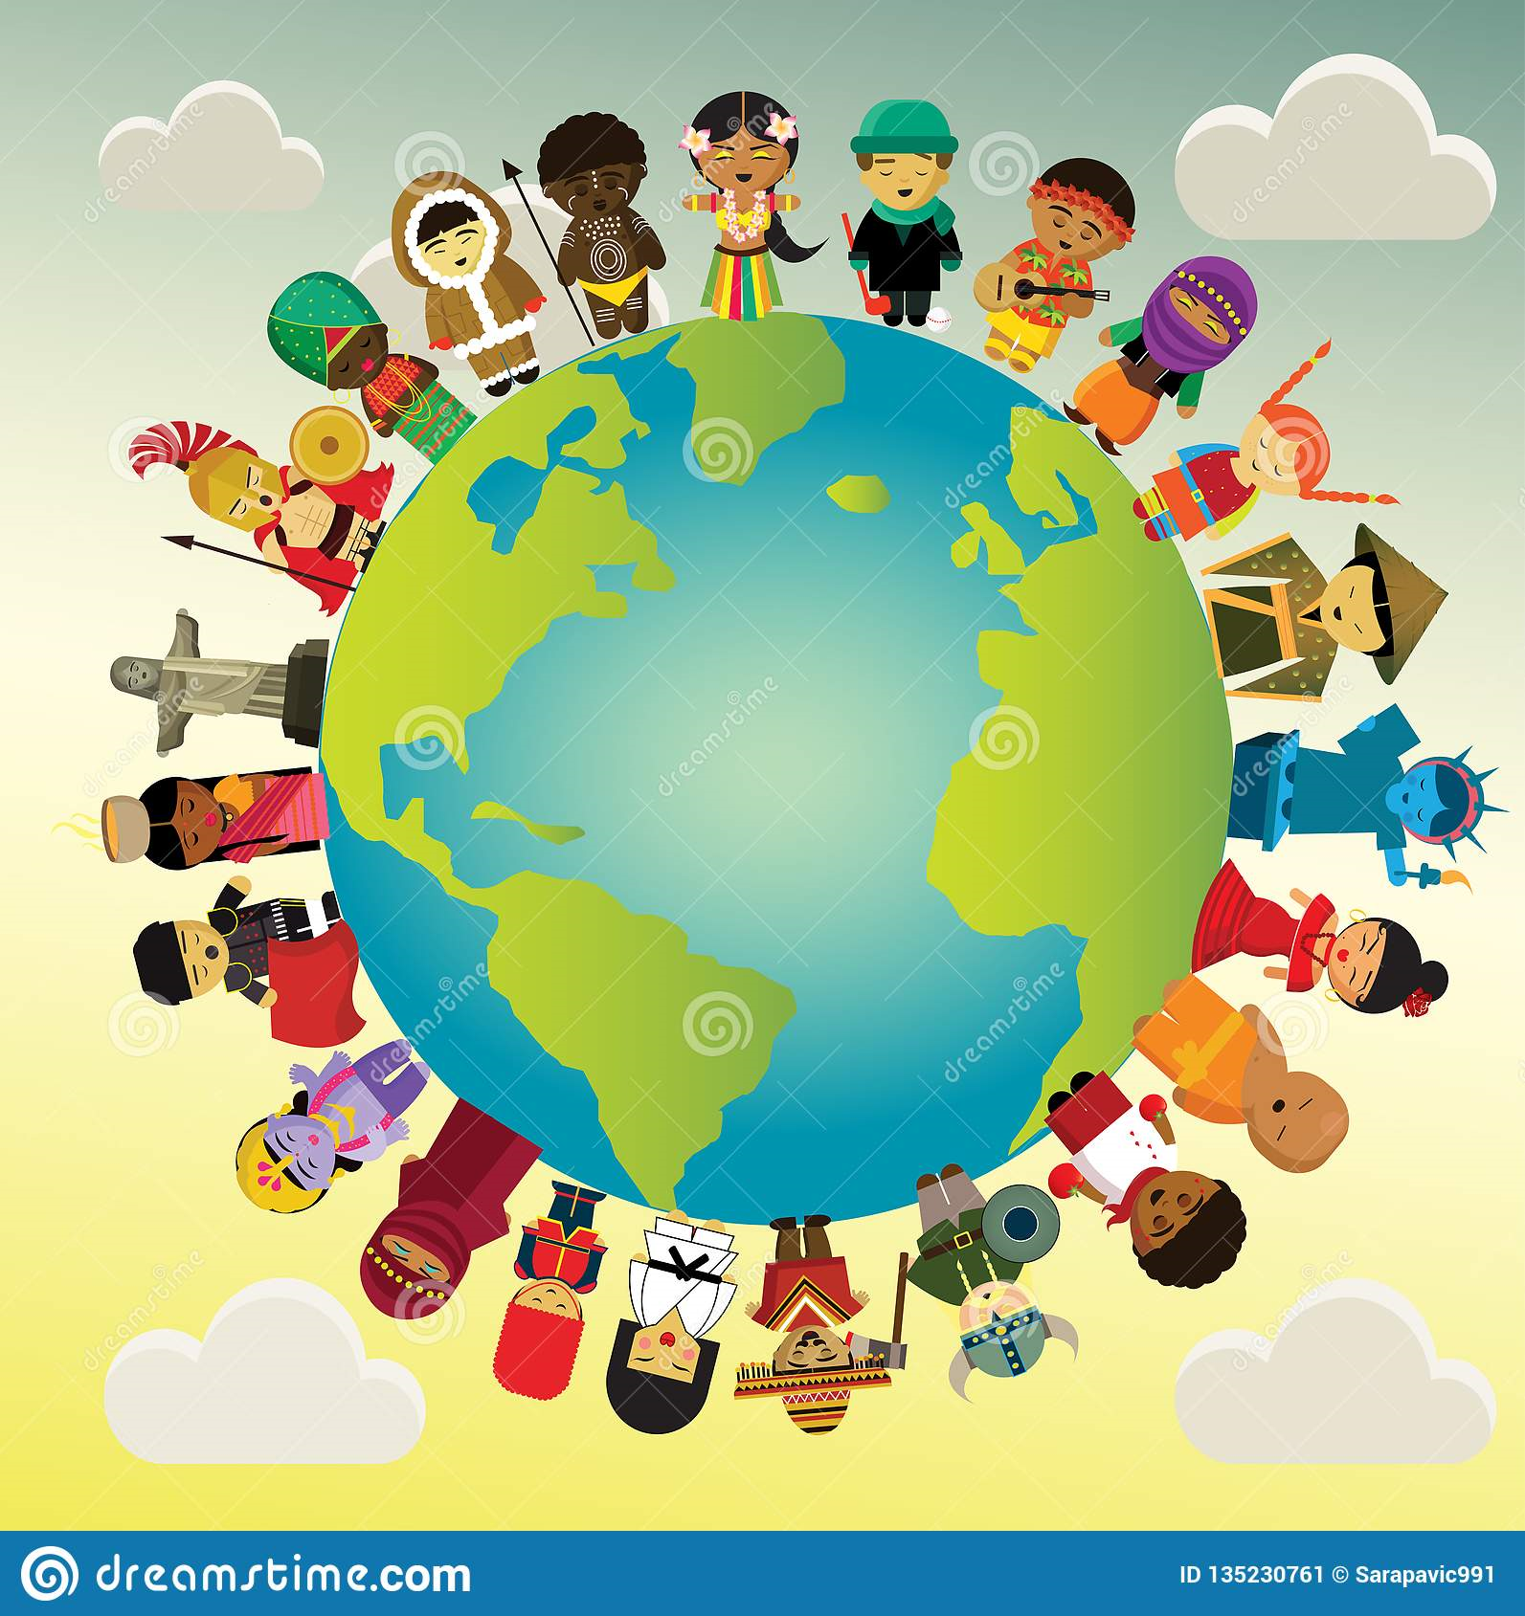

Pirate bunnies – ICT game
Visit this website and play this geography game. You can earn treasure by completing quests: discover the seven continents on the map, find the world’s five oceans and sail your ship north, east, south and west to get to the treasure. Plus many more activities.
Each quest will give you a golden coin and each golden coin will get you closer to the treasure! Sail away and practise your geography skills with this game.

Where in the world?
Have a discussion with your child about your own family heritage. Discuss with them your traditions and where your family originates from. This may be where you live now or it could be somewhere completely different. Ask your child to create a poster or PowerPoint all about their own family. Can they include a map identifying the country they’re from?

Speak the language:
There are lots of different ways to say hello around the world. Learn how to say hello in Spanish, French, Mandarin, German, Arabic and Italian with your child using Google translate.

STEM Learning Opportunities
Engineering Around the World - World’s Largest Steel Structure
● The Bird’s Nest is the world’s largest steel structure and was built in China for the 2008 Olympic Games. It is made out of 26 miles of steel.
● Use strips of paper, card or wool to create your own bird nest style building. You might like to search for photos of the ‘Birds nest’ to help you with your design.
Internet Safety Activities
The following links are intended to provide you with support and resources to help you learn about online safety at home with your child.
- https://www.thinkuknow.co.uk/parents/support-tools/home-activity-worksheets/
- Go to website for week 7 and 8 of the Think you know online safety at home learning pack. You will be linked to a series of videos called Jessie and Friends which are age appropriate animations that deal with online safety issues.
- This week you will think about chatting online and being kind. You will also think about playing games online, think about how to keep safe when online and play a board game to test your knowledge.
- https://www.childnet.com/resources/online-safety-activities-you-can-do-from-home

Additional learning resources
- BBC Bitesize-Lots of videos and learning opportunities for all subjects
- Classroom Secrets Learning Packs-Reading, writing and maths activities for different ages.
TT Rockstars/Monster Multiplication-Your child can access both of these programmes with their school logins. On Times Table Rockstars, children should aim to play Soundcheck for 10 minutes daily.
- IXL online. Click here for Year 1 or here for Year 2. There are interactive games to play and guides for parents

https://www.mathematicsmastery.org/free-resources. Take a look at the mastery mathematics home learning packs with a range of different activities and lessons
- Year 2 Talk for writing project and Year 1 are an excellent resource to support your child’s speaking and listening, reading and writing skills.

The Learning Projects are based on the National Curriculum expectations for the key stage which your child is in. If your child requires more of a challenge, or you believe that there are some gaps in their learning then Century Tech is a fantastic resource that is currently free for home learning. The app is designed to address gaps and misconceptions, provide challenge and enables children to retain new knowledge. It uses artificial intelligence to tailor the learning to your child’s needs. Sign up here.

