Monday: Natural Resources
Primal Painting

How to make your own natural paints
(Check out this website- https://www.funkidslive.com/summer-challenge/make-paints-plants-berries-powders/)
1. Push berries or other soft fruit through a sieve to extract your pigment
2. then mix with just a small splash of water!

Or

1. Grind petals, leaves, or other dry items
2. Mix with a tiny, tiny bit of honey!

Or
Powders are the easiest!
Just mix powders like mustard powder, cumin, or turmeric in water being super careful to add just the right amount.
You don’t want so much water that it’s super runny but you want enough so that it’s not grainy!
Another very old material to draw with is charcoal. Make it yourselves by putting pieces of wood in the flame of a candle. Remember to remind children to take care when using fire-always make sure they are under adult supervision. Children can then create any picture of their choice using their homemade paints.
See pictures on the next page.

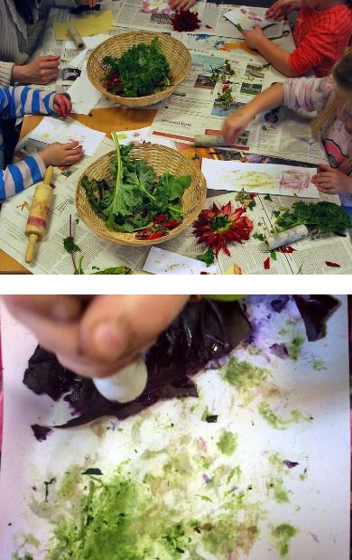

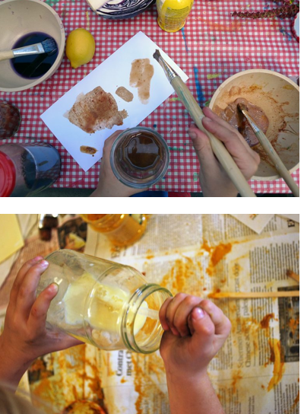
Tuesday: Land Art based on the work by David Goldsworthy
Focus- Colour
Based on David Goldsworthy’s Land Art, pupils are to create their own piece of art, with the focus on COLOUR.

Watch the video: https://www.youtube.com/watch?v=gdcmuiNj_mM

Show images of Mandalas by Andy Goldsworthy to see some good examples.

Collect a variety of items from nature. Think about the composition when collecting items, focusing on the colours. Do you want them to match or have a colour that stands out? Lay your items out to create a piece of art.

Remember to take a photo of it when it is complete.
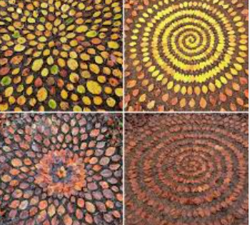

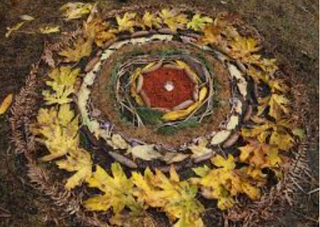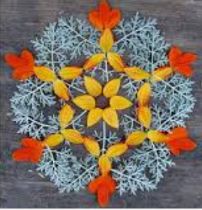
Wednesday: Drawing from nature
Make tree/leaf rubbings
Supplies:
- Different sizes and shapes of tree leaves (maple, oak, hackberry, mulberry, ginkgo)
- coloured paper
- crayons

Directions:

1. Put a leaf upside down on the table.

2. Place a piece of paper over the leaf.

3. While holding the paper and leaf in place, use the side of a crayon to rub across the leaf.

4. Make sure that you colour over the entire leaf. Rubbing firmly all over the leaf will show the veins and the outline of the leaf

5. A dark crayon will produce a clearer print of the leaf.

6. Do another leaf with different colour crayon.

Be creative.
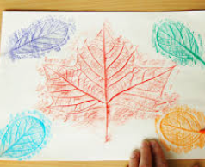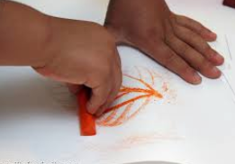

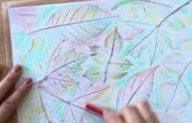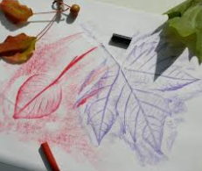

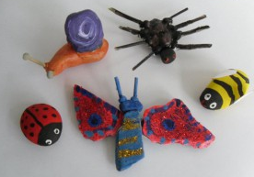
Thursday: 3D art
Design your own Mini-Beast
MATERIALS:

- assortment of pebbles/stones
- a few tiny twigs
- white paper or tissue paper
- acrylic paint
- paint brushes
- scissors
- PVA glue
- modelling clay (or blue tack will do!)
- glitter/ jewels/beads (optional)

INSTRUCTIONS:
1. Imagine what each pebble’s shape lends itself to. For example, a round fat pebble would be great for a bumble bee or a ladybird! A sausage shaped one would be good for the butterfly’s body!
Decide which pebbles are going to be used for which mini beasts
2. Ask an adult to help you when you are ready to stick some of the stones together to make the shape of the mini beasts or you’re sticking on the antennae or the spider’s legs. The best way to do this is to use a little ball or piece of clay covered in glue to help hold the stones/twigs in place
3. SNAIL – find a stone or pebble that is quite round for the snail’s house, then find a pebble for the body. Ask an adult to help you stick the “house” on top of the body. Leave to dry. Next stick on two tiny twigs for the antennae, then paint your snail with lovely bright colours!
4. BUMBLE BEE – paint a pebble yellow, leave to dry then paint the black stripes and a black face. Leave to dry. Cut out 2 wing shapes from the white paper/tissue paper and glue then on to either side of the bee’s body. Now paint a happy face onto the bee!
5. SPIDER – stick 2 pebbles together to make the spider’s head and body. Then use some thin twigs to stick 4 legs onto each side of the body. Next paint your spider & don’t forget to paint on some eyes! You could do a spotted spider or one with stripes! Choose any colours you like!
6. BUTTERFLY/MOTH – stick together two pebbles, one for the head and one for the body. Leave to dry. Next use two wing shaped stones or pebbles and stick these either side of the body. Now paint the body, the head and the wings! It is up to you which colours you pick, go wild and do some lovely patterns! If you have any glitter or beads around you can stick these onto the wings to make your butterfly extra colourful! Finally glue on two tiny twigs for the antennae.
7. LADYBIRD – paint the body all red. Leave to dry. Paint a black line down the middle of the body and a black face and black spots, if your pebble is big enough try using your fingers to paint the spots! and then to finish paint on some eyes!
8. Now your painted mini beasts should all be dry! I bet they look great! Where are you going to place them in your garden? or maybe they could live indoors in a plant pot on your windowsill
You could also try having really good look around your garden or the
park to see if you can find any real mini beasts!
See if you can spot any mini beasts under stones or leaves, on walls and
fences but remember not to touch them!
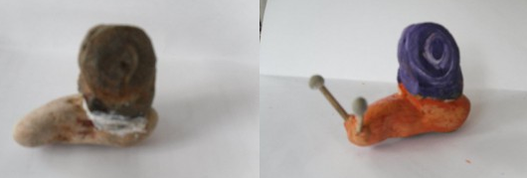
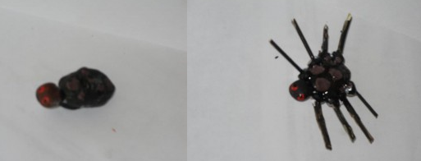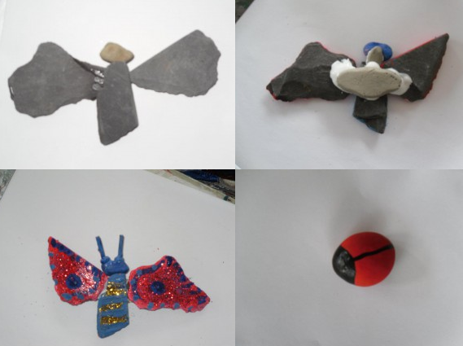

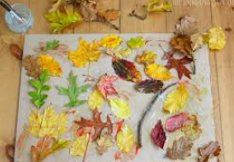
Friday: Natural materials Collage
Materials:
Paper- sugar paper A4 or A3
Leaves, Flowers, Etc
Scissors
Glue
Directions
- Go on a nature walk and collect flowers, leaves, and other bits of nature. You will need a lot for the collage.
- Sort the natural items into colours, size or shapes.
- Carefully choose an item and lay on the paper. Repeat this, arranging the items in any pattern, either space out or overlapping.
- Once finished, take a photo.
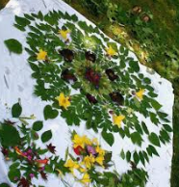
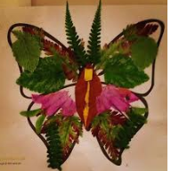
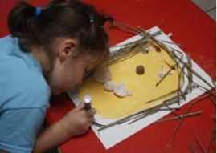
- You could then rearrange to make a new picture or glue down to create a finished piece of art.
