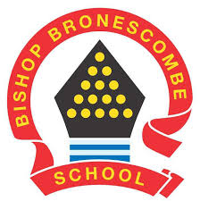
Learning Project WEEK 7 - Food

Year group: 1/2
Suggested Maths Activities  for Week 7 | Suggested Reading Activities  for Week 7
We wanted to make use of a brilliant online resource from white rose, so we will be adding links to these lessons. We also wanted to provide suggestions for practical activities based around these lessons for those families who want to limit screen time during home learning.  (Please be aware that the dates will not coincide with White rose dates, as we haven’t been using this resource since the start of lockdown ) | - If you have it, read ‘Handa’s surprise’, if you don’t have it, watch this link to watch it being read. Make a note of the adjectives that are used to describe the different fruits.
Year 1
https://whiterosemaths.com/homelearning/year-1/  Suggested lessons:  Summer term Week 2 – (w/c 27th April)  Lesson 1 – Find half (2)  Lesson 2 – Find a quarter (1)  Lesson 3 – Find a quarter (2)  Lesson 4 – Problem solving  Practical suggestions:  - Get a selection of lego blocks (or any item that you have a lot of), can you find half of the number of blocks?  - Can you find ½ of 8? ½ of 10? ½ of 14?  - Draw a selection of shapes. Can you split the shapes into 4 equal parts (quarters)?  - Get a selection of lego blocks (or any item that you have a lot of), can you find a quarter of the number of blocks?  - Can you find ¼ of 4? ¼ of 16? ¼ of 20? | - Find a cookery book in the house and read the ingredients and the method used to make something.
 | - Read a variety of books in your home; make a list of all of the different types of food in the books that you read.
Year 2
https://whiterosemaths.com/homelearning/year-2/
Suggested lessons:
Summer term Week 1 – (w/c 20th April)
Lesson 1 – Find three-quarters.
Lesson 2 – Count in fractions.
Lesson 3 – Measure length (cm)
Lesson 4 – Measure length (m)

Practical suggestions:
- Can the children use lego or blocks to find:
¾ 0f 12, ¾ of 16, ¾ of 20?
- Draw a grid and divide into 8 or 12. Show different ways of creating 3/4s of that number.

E.g.
- Use a ruler and measure lots of objects around the house. Can they estimate first how long they think it will be before they measure?
Suggested Spelling/Grammar Activities  for Week 7 | Suggested Writing Activities  for Week 7
- In KS1, we learn about 4 different types of words nouns (naming words), adjectives (these words describe nouns), verbs (action words) and adverbs (words that describes an action, i.e. they giggled loudly). Can you sort the following words into the correct category?  yellow, dog, walk, fresh, quickly, happily, table, jumped, slowly, ball, laptop, swim, carefully, beautiful, dangerous, shout | - Write a recipe for a healthy meal of your choice. Can you use subheadings for the ingredients and the instructions?
- Practise the Y1/2 common exception words and identify some words that you find tricky to spell. Use ‘quick write’ with these words. ‘Quick write’ is when you write a word (and ensure that it is spelt correctly) as many times as you can in 1 minute. Any words that are spelt incorrectly don’t count! | - Create a shopping list for the week. Can you group the different types of food into the different food categories i.e. fruit and vegetables, meat, dairy
- Can you make a list of words for the following spelling rules?  Rule 1: The ‘j’ sound can sometimes be spelt with a ‘g’ at the beginning or in the middle of words. (i.e. magic)  Rule 2: The s sound is spelt with a c if it is before e, i and y (i.e. city)  Rule 3: The n sound can be spelt kn and sometimes gn at the beginning of words (i.e. knot) | - Write a set of instructions for how to make toast.  - Can you use imperative (bossy) verbs?
Learning Project - to be done throughout the week
The project this week aims to provide opportunities for your child to learn more about the environment. Learning may focus on where different foods originate from, what makes a healthy meal and opportunities to cook etc.
Sorting activity:
Collect foods from around the house. Can you sort these foods into ‘healthy’ and ‘unhealthy’?

Balanced diet:
Watch this video about how to have a balanced diet. Play these games.
Look in the kitchen, can you create an A-Z of the different food items?

Get creative!
Look at the work of Giuseppe Arcimboldo. Can you create a picture like this of your own?
Or you may want to use the work of Lynn Flavell to inspire you to create your own fruit or vegetable themed piece of artwork. 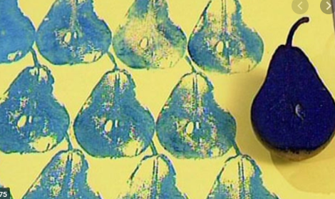

Healthy lunchbox
Can you play this game to create a healthy lunchbox?

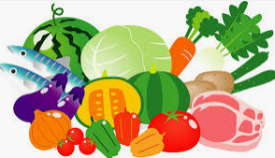
Traditional foods:
Find out traditional foods from different countries. This gives you an opportunity to find countries on a map as well as finding out which foods are eaten in that country.

Where does our food come from?
Discuss the fact that all of our food comes from either plants or animals. Watch this video book to find out more.
Now see if you can identify whether the items in your kitchen are from a plant or an animal.

How bread is made
Have you ever wondered how bread is made? Watch this clip and then see if you can draw and label pictures to show the process.
Additional learning resources you may want to engage with:
Classroom secrets learning packs: https://classroomsecrets.co.uk/free-home-learning-packs/
BBCBitesize daily lessons: https://www.bbc.co.uk/bitesize/dailylessons

