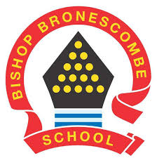
Learning Project WEEK 2- Area you live in

Year group: 1/2
Suggested Maths Activities  for Week 2 | Suggested Reading Activities  for Week 2
- Choose a number between 0-50, create a poster and show as many ways as you can of creating this number, think about additions, subtractions and then perhaps multiplications and divisions too.  If you enjoy this activity, you could try other numbers too! | - Improving fluency- listen to your child read and encourage them to read with expression and intonation. You may need to model this using echo reading- you read a short segment of text, sometimes a sentence or short paragraph, and your child echoes it back.
- Create a card game that can be used to make number bonds to 10 (i.e. 9 + 1, 8 + 2) or to 20 (i.e. 19 + 1, 18 + 2) and play the card game with your family. | - Read the poem ‘No place like home’ (this is at the bottom of this document) You could encourage your child to read it or you could read it to them. Discuss the fact that poem has repetition and rhyme as features. Get your child to find all of the rhyming words.
- Order numbers from 1 -100. You can practice using this game: Ordering numbers | - Discuss the features of fiction and non-fiction books. Gather some books from around the house and sort the books into ‘fiction’ and ‘non-fiction’ piles.
Suggested Spelling/Grammar Activities  for Week 2 | Suggested Writing Activities  for Week 2
- Revise what a verb is and then discuss adverbs which are words that tell us how we are doing something. E.g. Tom ran up the hill quickly. Ran is the verb and quickly is the adverb. Children to write five sentences with verbs and adverbs and to be able to clearly identify them. | - Find out as many facts as you can about the town/area in which you live. Write an informative paragraph using the information you have found out.
- Practice the alphabet and the order of the letters. Can the children then place five words in alphabetical order.  1 – steak, because, door, children, parents.  2 – Mrs, Christmas, again, poor, gold.  Children to pick five of their own words to order. Challenge the children to think about what happens when the words all begin with the same letter.  3 – egg, elephant, excellent, effort, eel. | On your daily walk in your local area make a mental note of all of the things that you can see, hear, smell and feel (or what you would be able to feel). When you get home, write a senses poem about your walk.  In my local area I can see………  In my local area I can hear……….
- Practise the Y1/2 common exception words. (The link comes out quite small, if you type Year 1/2 common exception words into google, the list is fairly easy to obtain | - Write a story about a character that comes to your local area, what do they do? Don’t forget the format of a story: Opening, build-up, Problem, Resolution, Ending
Learning Project - to be done throughout the week
The project this week aims to provide opportunities for your child to learn more about the area in which they live. Learning may focus on your local area, famous people, key landmarks and links to your town or county.
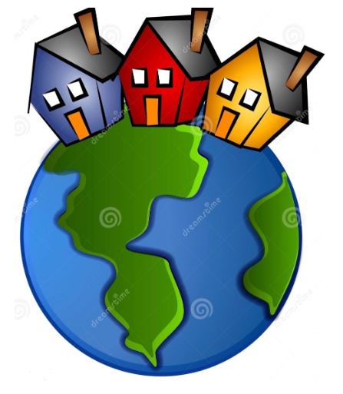
Children to draw a picture of their house. They can draw the outside of the house and inside their house. Then can they design their own future house with what they think it may look like.
Let’s wonder:
Here is the Cornish flag. What do you think the flag represents? What is the story of the flag? Can you design your own flag for your local area? What could you add? What would they mean to you?

Let’s create:
Create an individual passport to show your own information about where you live. Discuss the use of a passport. What is a passport? What information does it contain? What does a passport allow you to do? Can you find a real life passport? Do you have one?
Cornwall landmarks
Find out about some Cornwall landmarks. Create a poster about one or some of them showing information about where they are and why they are a special place to visit.

Let’s investigate:
Take your child on a shape hunt around their house and garden. Look at the different shapes of the windows, doors, and houses. Can they name them? Are they 2D or 3D shapes? Ask them to create a picture of their house or street.

Children to find their address on google maps. Spend some time investigating their local area and places they would like to visit in Cornwall or the UK.

