Monday
Leaf printing
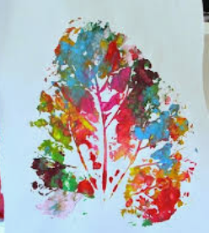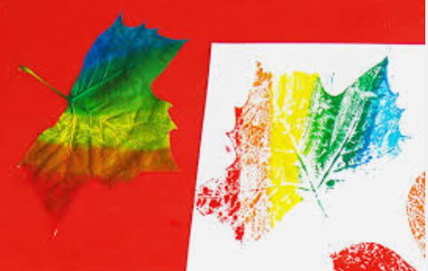
Making leaf prints is a simple idea that can easily be extended to create complex compositions.
- Begin by making a small collection of leaves – there’ll still be some left from autumn, but you could also cut some from plants that need containing, such as ivy.
- Squeeze a couple of blobs of printmaking ink onto a flat palette and use a plastic knife to mix two colours together.
- Flatten a leaf into the ink, remove it and press it on to the paper. Make several prints at this stage as you’ll find that each will be slightly different.
- Talk to children about the variety of tones and textures of the leaves – it often becomes more noticeable once it has been printed on to paper.
- Now think about composition. Repeating a pattern across the page or experimenting with rotating interlocking designs is an effective way of turning a simple activity into a more complex one.

Tuesday:
Land Art- Shape

Based on David Goldsworthy’s Land Art, pupils are to create their own piece of art, with the focus on SHAPE.

Watch the video: https://www.youtube.com/watch?v=gdcmuiNj_mM

Show images of Mandalas by Andy Goldsworthy to see some good examples.

Pupils collects a variety of items from nature. Think about the composition when collecting items, focusing on shape and patterns.

Remember to take a photo of it when it is complete.

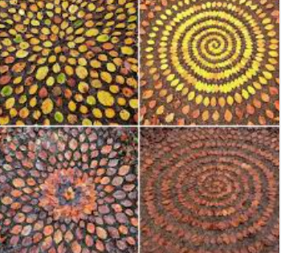
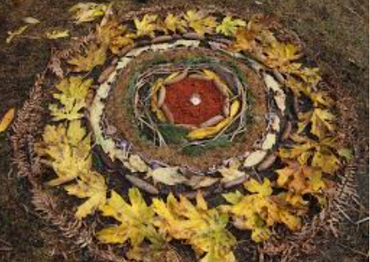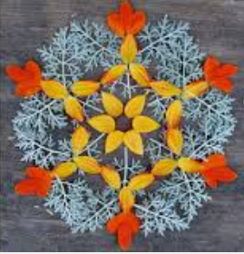
Wednesday
Patterns in Nature

- Use PowerPoint to discuss patterns in nature.
- Collect 4-5 natural items, such as leaves, flowers and grass.
- Study the patterns seen on each.
- Cut item in half and recreate the patterns by drawing the other half.
- Focus on the details you can see.
- Add colour once drawn, using colouring pencils.
- Take photo of your finished work for the online gallery.
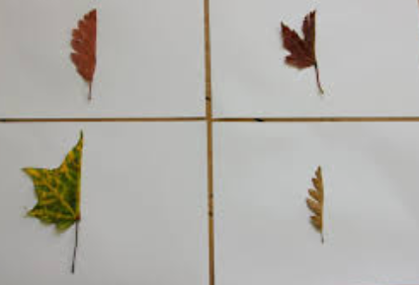
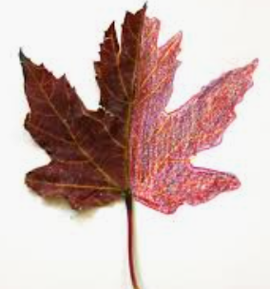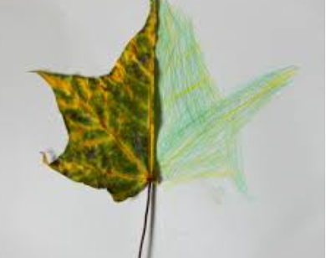

Thursday
Miniature Nature Sculptures

Collect natural materials to create a series of miniature nature sculptures.
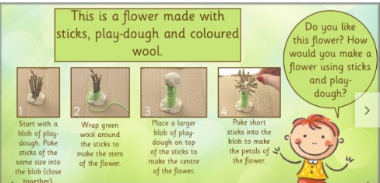

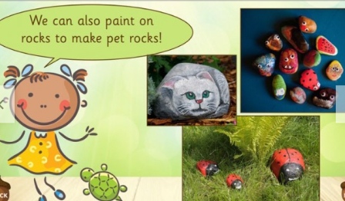

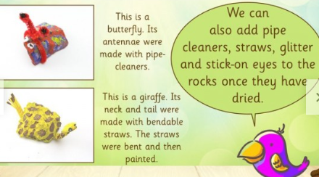

Friday

Creating a collage landscape

Watch this video for information on how to create a collage using various materials: https://www.bbc.co.uk/teach/class-clips-video/art-and-design-using-textured-materials-landscape-collage/zfrfbdm

In the video, she gives advice on making the best use of texture and colour, and using your imagination to make different materials represent real life objects.

Task:
Pupils to create their own collage of the landscape outside. Take a photo of the landscape if it is raining to use as reference.

Make a picture that can be explored by touch and hearing as well as sight.

Experiment with different textures, man-made and natural, to create specific effects.

