Learning Project WEEK 5- Animals

Year group: 1/2
Suggested Maths Activities  for Week 5 | Suggested Reading Activities  for Week 5
We wanted to make use of a brilliant online resource from white rose, so we will be adding links to these lessons. We also wanted to provide suggestions for practical activities based around these lessons for those families who want to limit screen time during home learning.  (Please be aware that the dates will not coincide with White rose, as we haven’t been using this resource since the start of lockdown ) | - Find adjectives in books that describe animal characters.
Year 1
https://whiterosemaths.com/homelearning/year-1/  Suggested lessons:  Week 2  Lesson 2 Counting in 10s  Lesson 3 – Make equal groups  Lesson 4 – Add equal groups  Lesson 5 – Make arrays  Practical suggestions:  - Count in 10s  - Find items that you have a lot of, i.e. pencils, lego blocks, and put these into equal groups. Can you share the objects equally? Can you find different ways that you can share the objects?  - Adding equal groups – Once you have put your objects into equal groups, can you write a repeated addition to add the equal groups together? I.e. 3 groups of 4 would be 4 + 4 + 4 = 12  - Make arrays – Create an array with your objects, an array is when you put your objects into rows. (As shown below)  This array shows 3 lots of 4 and 4 lots of 3. The total number of apples is 12. As an extension, you could write this as a multiplication 3 x 4 = 12 | - Listen to these stories about animals:  https://www.storylineonline.net/books/clark-the-shark/  https://www.storylineonline.net/books/library-lion/
Year 2
https://whiterosemaths.com/homelearning/year-2/  Suggested lessons:  Week 1  Lesson 1 – Make equal parts  Lesson 2 – Recognise a half  Lesson 3 – Find a half  Lesson 4 – Recognise a quarter  Lesson 5 – Find a quarter  Practical suggestions:  - Use lego or objects to make a total number. Practice finding ½ and ¼ of that number. Children need to divide the total into equal groups: 2 groups to find half and 4 groups to find a quarter. Count how many in one group.  - Draw a grid:  How many different ways can they colour in half? How many different ways can they colour in a quarter? Draw a different grid with a different number and explore halves and quarters. | - Create a bookmark with animal facts.
Suggested Spelling/Grammar Activities  for Week 5 | Suggested Writing Activities  for Week 5
- Play ‘guess the adverb’ have a selection of adverbs written down (an adverb describes how someone does an action, i.e. slowly, happily, loudly) and place them in a bag, get your child to select an adverb out of the bag and then act out a daily task in this manner. i.e. they could eat their dinner quickly, eat their dinner furiously, eat their dinner silently. Other players need to guess the adverb. | - Write a set of instructions for how to look after a pet. Think about what they would need to eat, where they would need to stay and what activities they might need to do each day to stay healthy.
- Think about conjunctions – these are words that are used to join two sentences, or parts of sentences together i.e. and, but, because  Get your child to say sentences that use conjunctions. To practise, you could play this game | - Write a fact file about your favourite animal. Research an animal of your choice and explore the vocabulary that you would need to use to describe them.
 | - A-Z animal list, can you think of a name of an animal for each letter of the alphabet? Write them down in a list in alphabetical order.
Learning Project - to be done throughout the week
The project this week aims to provide opportunities for your child to learn more about animals that they might be interested in. Learning may focus on exploring the physical aspects of the animal, their diet, their habitat etc.
Let’s sort:
Animals are grouped into three categories depending on what they eat. Herbivores eat plants, carnivores eat meat and omnivores eat a mixture of both. Watch this link to find out more. Can you sort a variety of animals into the correct categories? Play this game and try this quiz to find out more.

Find out about:
Nocturnal animals – what are nocturnal animals? Watch this clip and discuss which animals you saw. How are these animals especially adapted to be able to stay active at night and sleep during the day? Look at this link to find out more!
Let’s investigate:
What are mammals? What are fish? What are birds? What are amphibians? What are reptiles? What are minibeasts?
Find out more at:
https://www.bbc.co.uk/bitesize/topics/z6882hv

Let’s create:
Create an animal mask – using different materials around the house, create a mask of your favourite animal. Think about the colours and the shapes that you will need.
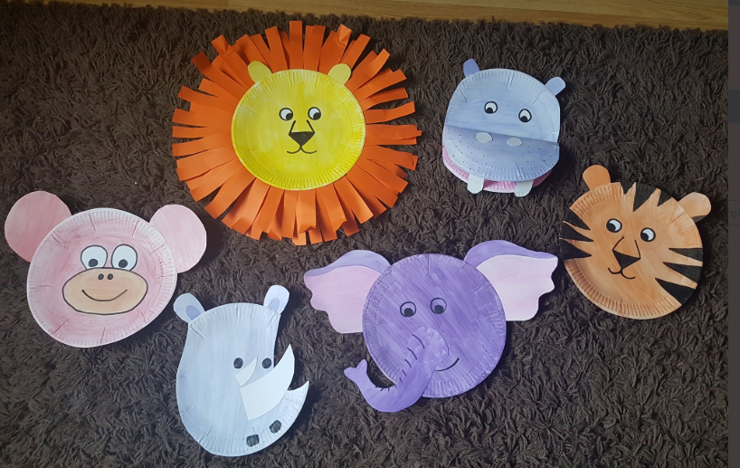

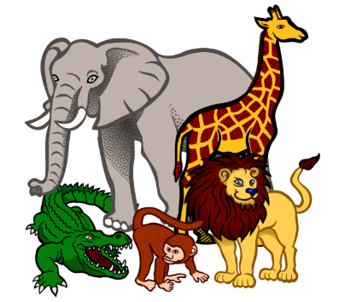
Let’s play:
Play a game where you act out animal characteristics and get other family members to guess which animal you are. Think about how the animal would move and what noise they would make.
You could play a game of ‘Who am I’ where you have an animal in your mind and other family members have to ask questions to find out which animal it is.

