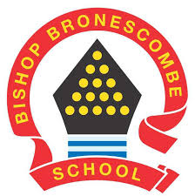
Learning Project WEEK 8 WC 08.06.2020- Celebrations

Year group: 3/4
Suggested Maths Activities  for Week 8 | Suggested Reading Activities  for Week 8
- TT Rockstars (please Dojo your child’s class teacher if your child is unsure of their login) TT Rockstars OR Monster Multiplication on Purple Mash (please Dojo your child’s class teacher if your child is unsure of their login) Purple Mash | - Listen to your child read a book or a chapter of your book. Discuss the book together and write a summary about the book you have read. What did you enjoy about the book? Would you recommend it? Why? Why not?
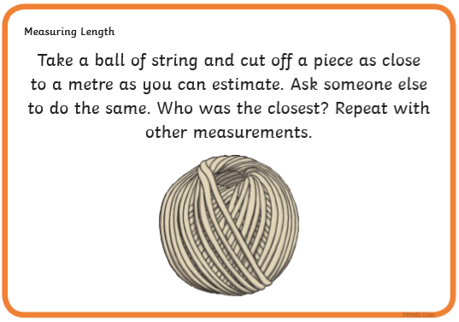 | - Can your child re-design the front cover of the book they are reading based on the information they have learned from the chapter they have just read. They wil need to consider the colours used, fonts used and use of imagery.
- WhiteRose Maths  Time  Converting between analogue and digital within 12 or 24hours.  Complete the worksheet (see separate worksheet on Website/ Class Dojo Pages) using Power Point to inform teaching/ challenge children further with problems to solve.  How can you identify whether the clock is analogue or digital? Can you identify any patterns between 12 and 24 hour time? How can you convert between the two? | - Challenge your child to find and read something around the house that isn’t a book. They can then record that in their reading record with a summary about it. Did you enjoy reading it? Would you consider it to be fiction or non-fiction? Why?
Suggested Spelling  Activities for Week 8 | Suggested Writing  Activities for Week 8
- Practise the Y3/4 Common Exception words.  You can use any technique you want to practise them with: rainbow writing, pyramid writing or mirror writing. | - Write a review of a party/ celebration you have been involved with and particularly enjoyed. What do you need to include to encourage other people to engage with the celebration? What style of writing is it... Fiction or non-fiction? Why?
- Choose 10 of your Year 3 and 4 expected words and spell them as “Magazine Words”.  Look through magazines and find and cut out letters from there to spell out your chosen words. | - Think of your favourite celebration and write an acrostic poem about it. Use sensory description to enhance your poetry. What could you see? What could you hear? You could include reasons for the celebration and your favourite/ least favourite parts.
- Flashcards. Using paper or card, create a set of flash cards for you to use to practise your chosen spelling words. Write the word on one side of the card and write the definition on the other side. | - Design and create an invitation for a celebration that you are hosting. What do you need to think about? How are you going to ensure people respond to your invite? What information do you need to include?
Suggested Learning Project: Celebrations
The project this week aims to provide opportunities for your child to learn more celebrations both in Britain and around the world. Why are celebrations important to people? What do they mean to different religions? Groups of people?
This project this week aims to provide opportunities for your child to learn more about celebrations. Learning may focus and different types of celebrations that take place and who may celebrate them. It could look at how people celebrate different events differently in other parts of the world.

● Let’s Wonder:
How are birthdays celebrated around the world? India China America Africa etc.. Maybe there's a particular country you would like to find out about. Create fact files to show the similarities and differences between them.
● Let’s Create:

Create a board game that focuses on celebrations. Think about what you can learn from it? Think about how to play the game. Is it going to be a game like Monopoly or Snakes and ladders? Are you going to need a dice? Cards? Characters? etc….

● Be Active:
Why not play a game of Hopscotch? Can’t find any chalk? Use a stone from the garden. Raining? Build an indoor den and have an imaginary celebration with their toys. Recommendation at least 2 hours of exercise a week.

● Time to Talk:

Look through old photos of previous celebrations you and your family have taken part in. What can you remember that happened? Why do you and your families celebrate the way they do?

● Understanding Others and Appreciating differences:

How many different types of celebrations are there? Who celebrates Christmas? St Patricks? St George? St David? Easter? Eid? Diwali? Chinese new year? And how? Which celebrations have you taken part in? What usually happens?

