- Review of expenditure
Previous Academic Year |  | 2018-2019
- Quality of teaching for all
Action | Intended outcome | Estimated impact: Did you meet the success criteria? (Include impact on pupils not eligible for PP, if appropriate). | Lessons learned  (and whether you will continue with this approach) | Cost
PP children to be a focus for regular pupil conferencing with teacher and ‘keep up’ interventions.  PP children to be a focus on monitoring visits.  PP children are named on planning so all adults know who they are and can target appropriately in lessons.  PP pupils to receive targeted interventions for core subjects.  Focus on:  Y3 – reading  Y5- RWM  Y6 – RWM | A. Reduce the attainment gap of pupils  deemed to be disadvantaged in Reading, Writing and Maths so that 70% reach age related expectations in Maths, 70% in writing and 75% in reading. | See attainment information for whole school PP below  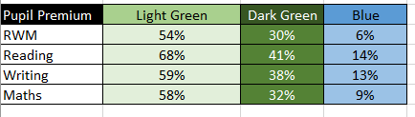  Target groups (Y6, Y5, Y3) see attainment information below  Year six.  Target met for Year 6 PP children with all areas exceeding 70%.  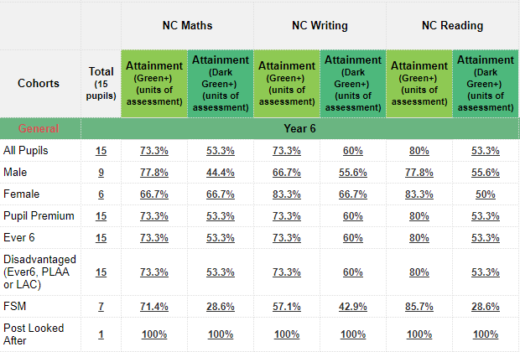  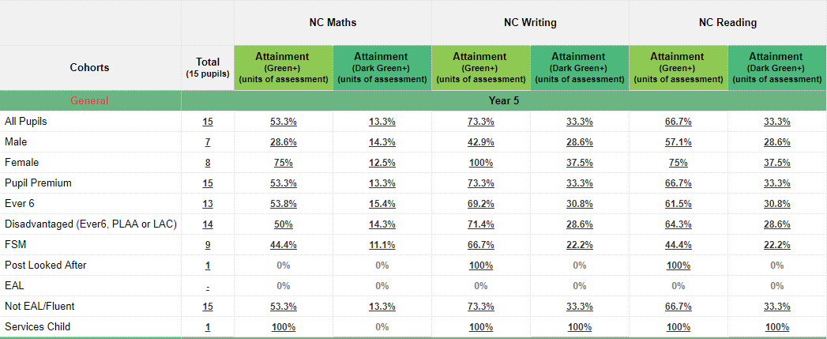  Year 5. Target reached for expected writing, but not in Maths or Reading  Year 3. Targets not met in all areas.  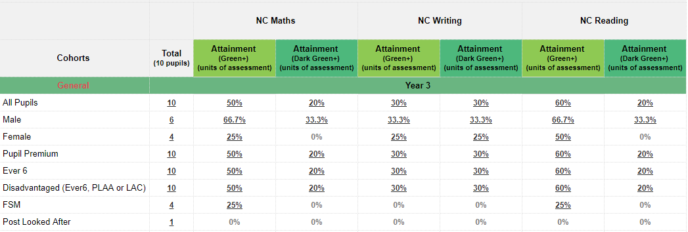 | PP children to continue to be a focus on planning and additional interventions when necessary.  Focus on quality first teaching within the classroom to target PP children.  Pupil conferencing to continue weekly for all PP children.  Targets need to more specific for each individual year group.  Breakdown of individual year group data needed to find focus areas for support when planning provision for next academic year. | £47,973  (total for i.)
Deployment of relevant PSA support.  Whole school TIS approach embedded x3 assigned practitioners.  TIS training for all new teachers and TAs to embed approach. | B. Social, emotional and behavioural needs are identified and action planned to best support outcomes of children. | 17 PP children accessing 1:1 TIS support with practitioners in Autumn.  16/16 have children made TIS progress. (1 pupil left us at the end of Spring term)  8 pupils made expected or better progress in all three subject areas (reading, writing, maths or Prime areas for EYFS pupils)  14 pupils have made at least expected progress in at least one subject area.  10 pupils have made accelerated progress in at least one subject area. | TIS support to continue for pupils in next academic year.  Class screenings to be completed to assess needs.  1:1 support planned and timetabled  TIS training for new staff to be completed at the beginning of the academic year.  TIS practitioners to have 1 afternoon out of the classroom to support pupils.  Impact to of pupils to be tracked termly and reported to SLT. Another full time member of staff to complete full 10 day TIS training.
Weekly attendance for each class published in newsletter  Attendance awards issued weekly to children achieving 100%.  Award for whole class weekly with highest attendance.  PSA to provide personalised support to families struggling with attendance issues. | D Attendance of small core of persistent absentee PP to continue to fall. | Whole school persistent absentees has reduced significantly and is currently (03.07.19) 5.05%.  PP persistent absentees has also reduced significantly. In Autumn 26.47% and is currently 14.08%.  PSA has supported 13 PP families with attendance issues.  Attendance is updated and published weekly in the newsletter.  112 attendance letters have been sent in total this year.  - 61 green attendance (96%-93%) letters sent  - 42 amber attendance (93%-90%) letters sent  - 9 red attendance (<90%) letters sent | Weekly attendance published in the newsletter makes all families aware of the impact that absence can have on each class’s attendance. This will continue next academic year.  Attendance awards weekly for individuals is not manageable but will continue to be issued termly.  The popcorn party allows children to take ownership of their own attendance and teachers remind and encourage children to attend school. This will continue.  PSA to work alongside and support families who are low attenders. Termly EWO meetings to continue and be led by PSA and SLT members.
Identification of chn and appropriate extension tasks identified on planning  Daily opportunities provided as Maths Masters/Star writers  Provide ‘aspirational’ opportunities for students  Pupils to have access to a wider range of enrichment activities.  Y5/6 teachers to build a strong working relationship with local secondary schools. | E. All HAPs/G&T PP children to maintain their projected academic pathway so that 20% meet GD in reading, 20% in writing and 20% in maths. | See whole school GD results below.  Individual year group targets that have been met – see below  Y6 writing – 20%GD  Y4 writing – 20% GD  Y4 reading -20% GD  Y3 maths – 20% GD  Y3 reading – 20% GD  Y2 reading – 25% GD | All PP children are noted on planning but it needs to be more specific as to who is a HAP PP child.  Relationship between Y5/6 teacher and secondary school growing but limited to access to secondary school before the summer term. Links with secondary schools to start earlier in the term.  Enrichment opportunities and aspirational opportunities still needs to be improved for HAP and G&T children.  Targeted intervention teachers to be used for HAP children as well as LAP children.  Individual year group data needs to be analysed to find target year groups and areas.
- Additional Targeted support
Action | Intended outcome | Estimated impact: Did you meet the success criteria? (Include impact on pupils not eligible for PP, if appropriate). | Lessons learned  (and whether you will continue with this approach) | Cost
PP children to be identified for intervention.  Interventions provided at least 3 x weekly to tackle underachievement in Reading, Writing or Maths  Pupil conferencing at least 3x a week to support those underachieving.  Additional intervention TA in Y6 for PP children to deliver targeted support | A. Reduce the attainment gap of pupils deemed to be disadvantaged in Reading, Writing and Maths. | 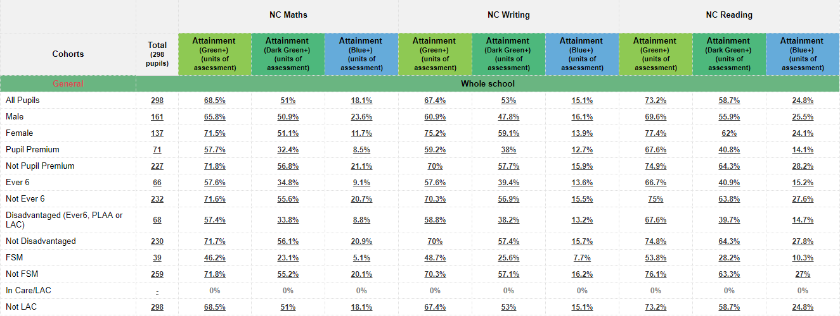  The attainment gap is narrowing but not quickly enough. Progress is not accelerated across the whole school, leaving PP pupils performing below their peers.  See data below | Focus on quality first teaching and teacher based pupil conferencing is needed throughout all classes.  Interventions to continue to be used when necessary.  Additional Y6 TA will not be available from September 2019 but intervention teacher will still be in place. Focus on closing the gap for PP children.  Analysis of year group data to find focus areas and target groups. | See breakdown below
Action planning and support from appropriate internal/external agencies.  Deployment of relevant PSA support.  Whole school TIS approach embedded. Practitioners to have half a day out of the classroom and 1 hour after school to complete 1:1 TIS plans and support teachers and TA with delivery.  Use of hardship funds for trips/clubs/breakfast and after school club.  Pupil Premium pupils are targeted in BLP research projects | B. Social, emotional and behavioural needs are identified and action planned to best support outcomes of children. | PSA supporting on average 20 families a month with approx. 50% of these families being PP families. Both internal and external referrals have been made to a wide variety of agencies including domestic abuse support, bereavement support, early help and family support.  9 PP pupils have accessed hardship funds over the course of the year.  2 pupils – wrap around care  2 pupils – singing lessons  5 pupils – school residential  Whole school TIS screenings completed by teachers at the end of term to identify individuals or groups that need support in next academic year. | PSA to continue to support families 2.5 days a week. All families worked with will continue to be logged as will referrals made to outside agencies.  Hardship fund to be used more readily in next academic year. Parents to receive a letter with home school agreement outlining what PP funding is and how it is used within school and what parents can access in terms of financial support. Music lessons to be offered to PP children.  TIS groups / individual support timetables to be set up and information to be shared with parents.  BLP to be more focused on resilience and confidence building moving into next academic year.
Individuals have access to a 1:1 TA  Named intervention TAs to be timetabled at least 3 afternoons per week to deliver targeted interventions to promote ARE outcomes in R/W/M and RWI.  Draw and Talk accessed to support identified needs  Pupil premium underachieving children to be targeted for regular pupil conferencing in Maths and Writing.  Intervention teacher to be contracted to work 4 mornings per week. | C Children with specific or individual needs are supported effectively. | Named TAs deliver interventions planned by class teachers. Pupils chosen to complete based on pupil progress meetings. Targeted PP children clear on progress documents.  PP pupils identified for additional pupil conferencing on planning and keep up / moving on activities delivered.  Intervention teacher worked with Y6 pupils.  Y6 PP results  Maths – 60% (9/15) ARE  Reading – 53% (8/15) ARE  Writing – 73% (11/15) ARE  SPaG – 47% (7/15) ARE | Interventions need to be more specific for PP children and logs need to be kept up to date and clear on PP trackers.  Pupil conferencing with class teachers to continue to move children on in their learning through the use of quality first teaching.  Intervention teacher’s group to be clearly identified on planning and PP children made clearer.
Early EWO referrals with SLT  PSA/SLT support given to help overcome barriers  Attendance incentives to be awarded across the school  Attendance letter to go home to those who’s attendance drop below 93% | D Attendance of small core of persistent absentee PP continues to rise | Summer 2 attendance report  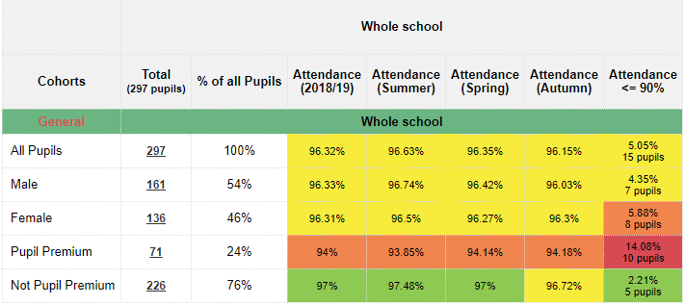  PP persistent absentees has reduced significantly. In Autumn 26.47% and is currently 14.08%. | PSA / SLT to continue to work with families on a weekly basis to support in improving attendance.  EWO meetings will continue termly and referrals will be made for targeted families.  Attendance incentives to be continued to engage pupils.
Identification of children as being likely to achieve Greater Depth and targeted in English and Maths.  Intervention 4 x weekly in year 6.  Provide ‘aspirational’ opportunities for students  Maintain good links with the local secondary schools. | E. All HAPs/G&T PP children to maintain their projected academic pathway. | Desired outcome not met as a whole school. See whole school GD results below  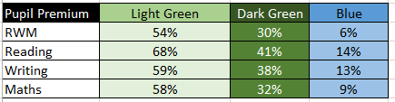  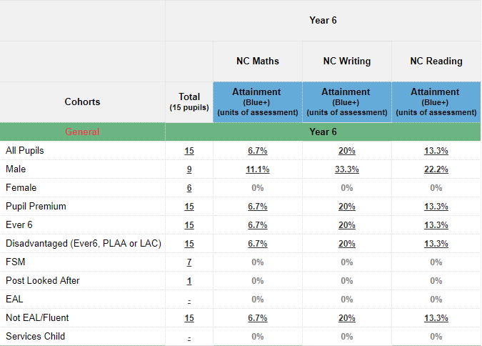  Year six GD teacher assessment data see below – Target met for Writing | Y6 intervention teacher to continue into next academic year.  G&T PP children to be identified at the beginning of the year and provision to be mapped out with class teachers.  Contact with the secondary schools to be improved through the Y6 teachers and G&T events planned in advance.  Aspirational opportunities for G&T PP pupils to be planned with Y6 staff at the beginning of the academic year.
Staff trained in Early Help services  Early Help identified and promoted from entry level and above  Relevant agency details promoted and referrals made, including MARU  Inclusion of the ‘TIS Approach’ and an associated lunch time nurture group with allocated TIS practitioner  TIS practitioners to have half a day out of the classroom and time after school to work, monitor and plan alongside teaching staff. | F. Relevant intervention is provided to support children’s social, emotional and behavioural well-being. | - PSA supporting on average 20 families a month with approx. 50% of these families being PP families. Referrals made to a number of outside agencies and support given in writing referrals for early help. PSA keeps in regular contact with families via phone calls, texts and emails and logs actions on CPOMs.  - Class teachers refer parents to PSA for support when needed.  Approx. 6 pupils accessing ‘lunch club’ (KS2) during autumn term, with now between 1 and 3 accessing daily. This number increases during transition times. When no children access this provision, TIS practitioner goes out to the playground to support children.  6 children accessed ‘Nurture’ provision which was set up in the Autumn term. This is led by a TIS practitioner. Now only 4 children access this provision full time, with one other joining at lunch times. | PSA to continue to work with all families including PP families.  Lunch club to continue to be run by a TIS practitioner with an emphasis on positive transition during Autumn term.  Nurture provision to continue to be run by TIS practitioner, with support in place to support transition for these children.
Targeted children attend Early Morning Maths daily.  PP children are identified on teacher’s planning.  Identified families attend Maths specific family learning sessions.  Maths interventions focus on keeping up and moving children on in their learning.  Maths homework completed by all targeted children. | H. Arithmetic and reasoning in Maths improves through targeted exposure in Early Morning Maths, ‘keep up’ interventions and through targeted family learning sessions. | 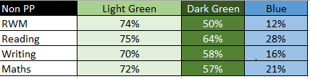  See whole school PP and non- PP maths results below –  Limited uptake for family learning and did not go ahead.  Early morning Maths planning target gaps in children’s learning. | Morning maths accessed by most children but not all PP attend sessions. Target families and speak with parents.  Family learning to be focused for PP families and invites to be sent to targeted families. After school option to be provided.  Interventions planned based on pupil progress meetings and PP pupils needing support identified.  Tailored homework to continue and support given to those who do not receive it at home.
Breakdown of staff costings over 12 months
PSA / Intervention teacher / Intervention TA
Total - £46, 818.36
Costing for additional resources
Total - £47, 781.64
- Other approaches
Action | Intended outcome | Estimated impact: Did you meet the success criteria? (Include impact on pupils not eligible for PP, if appropriate). | Lessons learned  (and whether you will continue with this approach) | Cost
PSA direct support for children and families  PSA referrals to parenting workshops  Establish Family Learning across the school, starting with early support in reception/Y1.  Review methods of communication with parents (investigate social media options)  KIDS MATTER parenting workshop programme to target identified families | Parents / families in need of extra support are identified and their parenting capacity is strengthened | PSA supporting on average 20 families a month with approx. 50% of these families being PP families. Both internal and external referrals have been made to a wide variety of agencies including domestic abuse support, bereavement support, early help and family support.  KIDS MATTER programme – 14 families have accessed over the programme over two course. Families have discussed the positive impact of behaviour strategies at home with members of SLT. Support and referrals to additional agencies have been made through the programme which have led to family and early support.  Family learning was not as successful this year with limited number of PP families attending.  Methods of communication improved; text, dojo, newsletter, phone calls, EYFS facebook page are all used to communicate with parents.  Parent survey sent out with 99 returns. No question regarding communication given, but 13% of parents commented on how it worked well and had improved over the last year.  Whole school dojo being used to communicate positive school events with all parents. | PSA support to continue 2.5 days a week next academic year.  KIDS MATTER programme to continue in the next academic year and PP target families to be invited to attend.  Family learning to target PP families by inviting targeted families.  Methods of communication to continue to be used. Whole school dojos to be used when appropriate and more readily by staff. | £400

