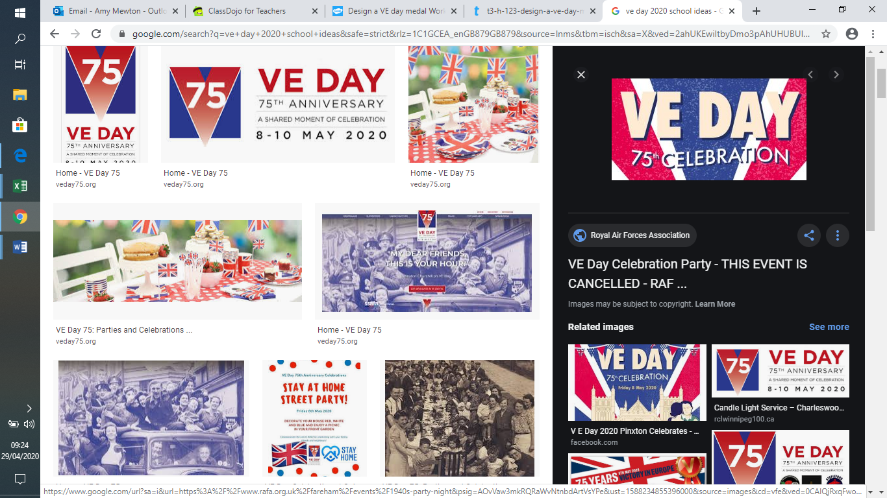

**VE Street Party Diary**

Your task is to choose one person from this street party on the 8th May, 1945 and write a diary entry for them about how they felt about the war ending. You may like to consider the following questions:

* Have they seen the Blitz?
* Do they know someone fighting?
* Have they lost anyone in the war?
* How have they coped with rationing?
* Have they been evacuated?
* Do they expect things to return to normal?
* Has the war changed the world?

**Wartime Music**

Why not listen to some wartime songs. Which one was your favourite? What instruments could you hear? How did it make you feel?

You might like to create a piece of art work around your favourite song or even have a go at creating and performing your very own wartime song.

**Design and make your very own Spitfire**

Why not research Spitfires and then either choose your favourite or create your very own design. There is a template on the school website if you have access to a printer at home.

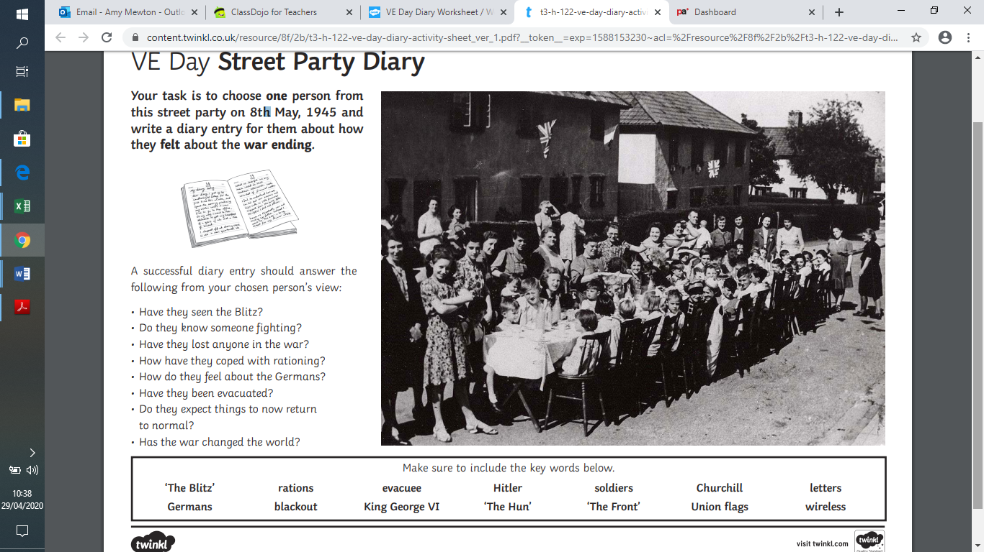

**Great British Bunting**

On Friday 8 May, Britain will be commemorating the 75th anniversary of VE Day when the guns fell silent at the end of war in Europe. Due to the coronavirus restrictions, most VE Day 75 events and street parties have had to be cancelled or postponed but we still want you to be able to mark the occasion, share your pride in our country and honour the men and women of WW2.

You can make your own special VE Day 75 ‘Great British Bunting’ to display in your window at home. Follow the link below with all of the instructions you need to get started using any paper, cereal boxes, string, ribbon, sweet wrappers, felt pens, poster paint you have or whatever you can find.

You can decorate your bunting with pictures of whatever inspires you, whether it’s those who fought on the frontline or worked hard on the Homefront, or whether it’s a celebration of enduring peace or your own personal hero. Hang your bunting with pride over the weekend of Friday 8 May - Sunday 10 May and make sure you share your pictures with us.

<https://www.bbc.co.uk/programmes/articles/4TrqYDyf4PMdLypxzyTwGDg/great-british-bunting>

**Wartime Recipes**

During the 1940s and 50s, food was rationed so only certain foods were available to buy. Follow the link below and have a go at creating one of your very own wartime recipes.

<https://the1940sexperiment.com/100-wartime-recipes/>

**Design a British medal**

Your task is to create a medal for British soldiers who served in the Second World War. Your medal can be any shape or size but you must have considered the metal and ribbon choices.

You must include:

* The years of the war ( 1939-45)
* The colours of the Allies
* A symbol to signify the war and the soldier’s sacrifice and victory.
* A reference to the many theatres of the fighting ( Europe, Africa, Asia, Sea, Land)
* Annotations to explain your choices.