Monday
Making natural paints for self portraits

How to make your own natural paints
(Check out this website- https://www.funkidslive.com/summer-challenge/make-paints-plants-berries-powders/)
Push berries or other soft fruit through a sieve to extract your pigment, then mix with just a small splash of water!
or
Grind petals, leaves, or other dry items before mixing with a tiny, tiny bit of honey!
or
Powders are the easiest! Just mix powders like mustard powder, cumin, or turmeric in water being super careful to add just the right amount. You don’t want so much water that it’s super runny but you want enough so that it’s not grainy!
For the self-portrait:
- Take a photo of child to use as reference.
- Trace over the image.
- Lay the tracing paper upside down on a sheet of paper or card. Tape in place.
- Draw over the lines you drew before.
- Remove tracing paper. You have now transferred the image onto the paper.
- Go over the lines in pencil.
- Use natural paint to add colour to your self portrait.
- Take a photo of your self portrait.
Use this website for detail on tracing paper transfers
https://www.wikihow.com/Trace-Using-Only-Tracing-Paper-and-Pencil-Lead-for-Visual-Artists#:~:text=Obtain%20a%20new%20surface%2C%20such,paper%2C%20to%20transfer%20your%20drawing.&text=Place%20the%20drawing%20paper%20on,and%20secure%20it%20with%20tape.&text=Place%20the%20tracing%20paper%20gently,it%20in%20place%20as%20well.

Tuesday:
Land Art- Line

Based on David Goldsworthy’s Land Art, pupils are to create their own piece of art, with the focus on Line and Space

- Watch the video: https://www.youtube.com/watch?v=gdcmuiNj_mM

- Show images of art by Andy Goldsworthy to see some good examples.

- Pupils collects a variety of items from nature. Think about the composition when collecting items, focusing on lines and space.

- Create art work. Take time to make it really accurate. What could be improved?

- Remember to take a photo of it when it is complete.
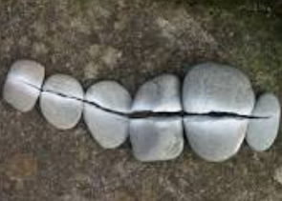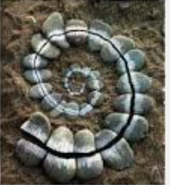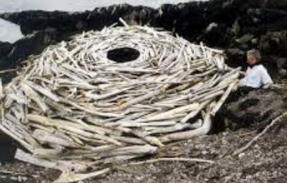
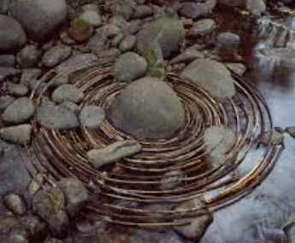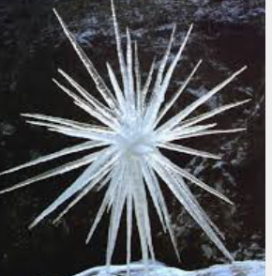

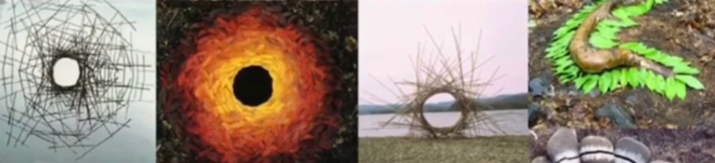
Wednesday
Typography- Natural and Man-made
- Talk about some of the typefaces we are familiar with, and how easy it is using computers to experiment with different fonts for different purposes.

- Introduce the idea that someone somewhere had designed the typefaces, just like someone designs the cups and plates and cars we use, and that this is the art of typography.

- Get the children to begin with some observational drawing, not only to give them a starting point for their typography, but also to reinforce the relationship of drawing to design.

- Present the children with three very different starting points in terms of subject matter: 1) pieces of metal, buts, bolts, screws etc, 2) twigs and 3) grasses.

- Ask the children to study the subject matter and search out shapes which reminded them of letters, or even pick the subject matter up, and start to make letters out of the elements.

- Remind the children of the difference between upper and lower case letters. Give out sheets of paper for them to work on – uppercase letters were drawn on A4 sheets, lowercase letters on A5 sheets.

- Ask the children to think of their letters as having substance, i.e. being chunky – not just lines on a page.

- Encourage them to draw their letters to fill the sheets- careful, slow, looking and mark making. Children to make rough sketches in pencil before going over their lines in pen.

- Take photos of finished piece.
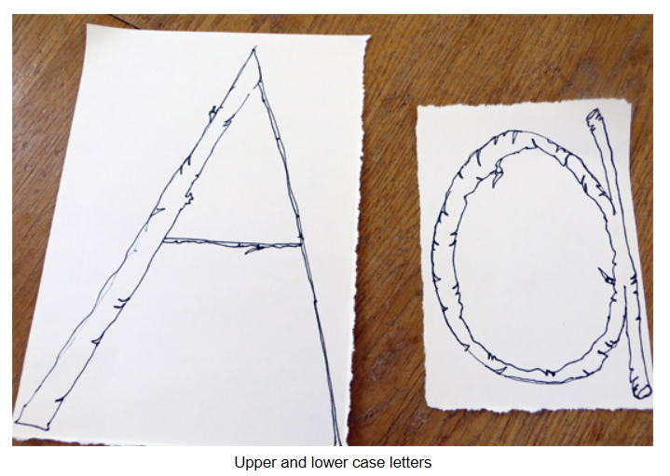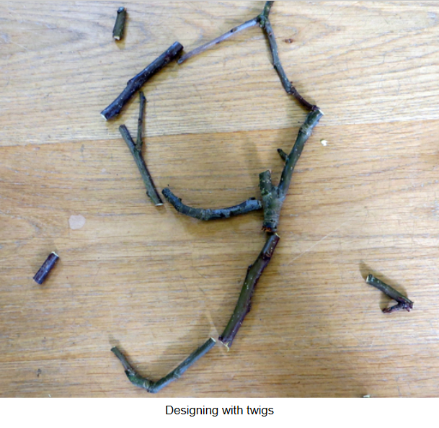
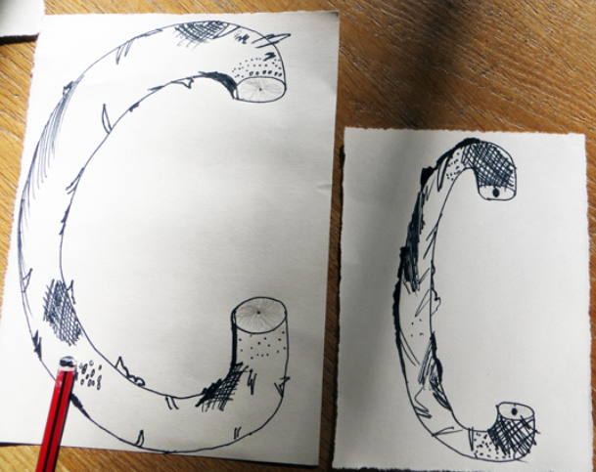
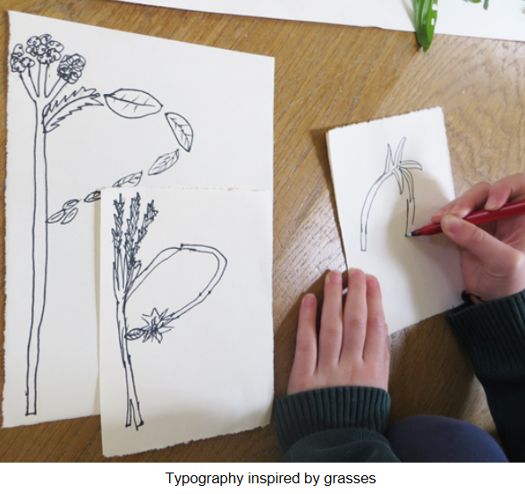

Thursday
Sculpture houses out of Natural and Man-made materials
Making sculpture houses out of Natural and Man made materials
We’re Making Sculptures not Models!
What does that mean? What might a model be? What might a sculpture be? When you make a model, you are making a smaller version of something. When you make a sculpture, you can let your ideas fly!
Opportunity: Make your sculpture as individual as you are!

Making Sculpture can be Frustrating!
It’s hard to shape and join materials, things fall over and break. Hands get sore and brains get tired!
Opportunity: If you are finding it hardwork, don’t worry – that means you are really doing it! Remember: If you have a sculptural crisis and feel fed up, it could be that the breakthrough is just round the corner! Take a breath, be inventive and take risks!

Don’t Design on Paper First:
Don’t draw your sculpture first – it’s very hard to make something with materials when you have too clear an idea in your head…
Opportunity: Instead, pick up the materials and tools and let them lead you.
Lastly, give your sculpture as much PERSONALITY as you can. Throw YOURSELF into your work!
Without over doing the demonstrations (as too many demonstrations can lead too strongly), illustrate ways of creating structure and armature, and ways of fastening materials together. The emphasis should be on encouraging inventiveness through an exploratory approach. Encourage children to get started by gathering the materials they were most attracted to.
– sticks, withies, small pieces of wood
– wire (various thicknesses for structure and binding)
– corrugated cardboard, paper
– raffia, string
– hessian, calico, felted wool
– strong pva glue
– scissors, pliers

Collect natural materials from outdoors and other manmade items from indoors.
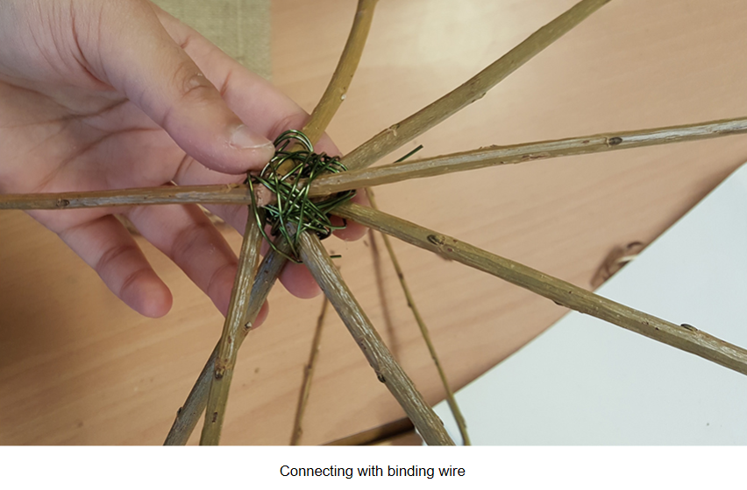
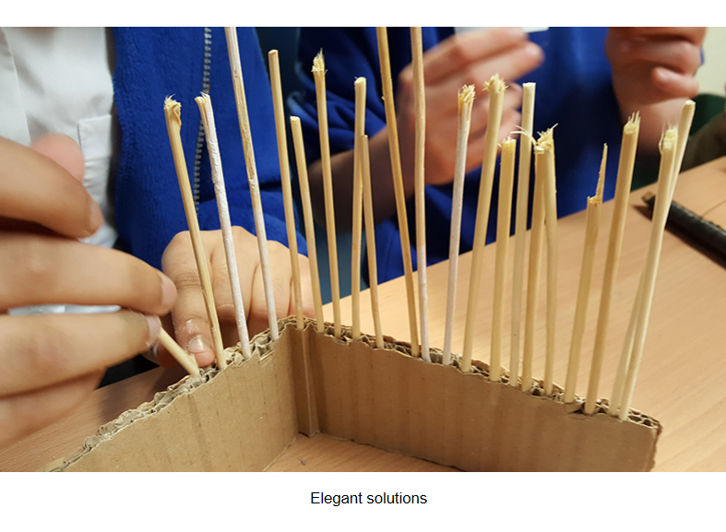
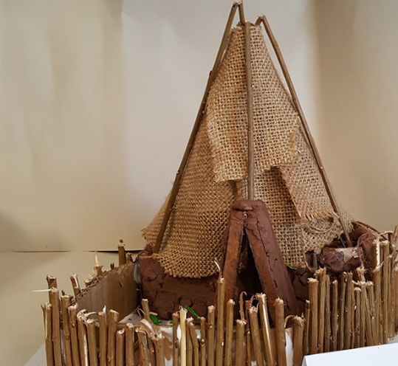
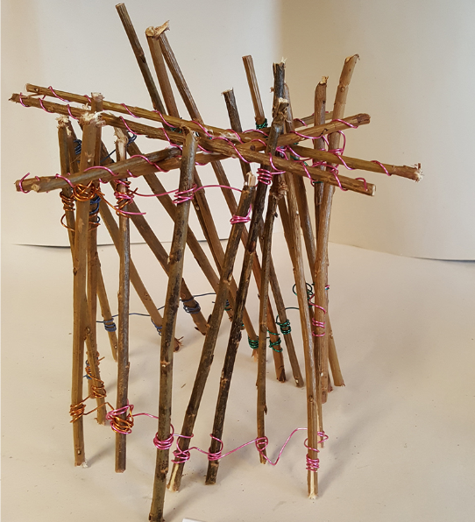

Friday
Collage-Backdrop for Sculpture of house using natural and man-made materials
- Watch this video to remind how to create a collage: https://www.bbc.co.uk/teach/class-clips-video/art-and-design-using-textured-materials-landscape-collage/zfrfbdm
- Explain that children are going to use the collage technique to create a backdrop for the sculpture house they created yesterday.
- Show pictures below to give inspiration.
- Children to collect a variety of natural and man-made materials to create their collages.
- Once complete, place yesterday’s sculpture in the forefront.
- Decide on a name the collage, in the style of the ones below.
- Take photos of the finished piece.
