Learning Project WEEK 2 – The Area You Live In

Year group: 5/6
Suggested Maths Activities  for Week 2 | Suggested Reading Activities  for Week 2
- TT Rockstars ( please Dojo your child’s class teacher if your child is unsure of their login) TT Rockstars  Each child has been allocated times tables to practise based on their targets. | - Your child can continue to read a chapter from their reading book. This could be outside, in a reading space that you may have created last week, or you could challenge yourself – where is the most unusual space that you can find to get comfy with your book?!
- Reach 1000- draw a 2x2 grid. Choose four different digits from 1−9 and put one in each box. For example:  This gives four two-digit numbers:  52(reading along the 1st row)  19(reading along the 2nd row)  51(reading down the left hand column)  29(reading down the right hand column)  In this case their sum is 151  .  Try a few examples of your own.  Is there a quick way to tell if the total is going to be even or odd?  Your challenge is to find four different digits that give four two-digit numbers which add to a total of 100  How many ways can you find of doing it? | - After this, ask your child to write a short review detailing their likes and dislikes about the novel so far. Encourage them to justify their opinion with examples from the text.
- Learn fractions whilst baking- choose a recipe of your choice. Once it is baked, you can chat about adding and subtracting fractions. For example, if you were cooking a batch of 24 biscuits you could use mathematical talk such as, so if I have 4 biscuits (4/24) and you have 4 biscuits (4/24), how many of the biscuits do we both have (8/24) and is there a way of making that fraction smaller (1/3)? Then if you gave 2 of your biscuits to a friend, how would you work out the new fraction? | - https://authorfy.com/join/  Authorfy allows you to join for free and to access masterclasses from a range of authors. You can either search by age, or by selecting one of your favourite authors from the list.
Suggested Spelling Activities  for week 2 | Suggested Writing Activities  for week 2
- Encourage your child to practise the Year 5/ 6 Common Exception words Choose 10 of the words and create a word search for someone in your family to complete in a 15x15 grid. Choose 10 new words and repeat. | - What is a day at home like for someone else in your family? Write a diary entry for a day in the week from someone else’s point of view – maybe a parent or a brother or sister. If you have a pet, maybe you could write what they see your family do during the day. Remember in a diary you are writing in 1st person and you are describing the main events of the day and how the person feels about them.
- BANG: Choose 10 common Exception words which are written on card/paper and placed in a box or bag. The player picks a word and reads it out loud, then turns the card overs and spells aloud the word. If they are correct they can keep the card, and it is the next player's turn. The object is to have the most cards at the end of the game. "Bang" is written on some cards. When a player chooses Bang they have to read BANG in a nice loud voice and put ALL of their cards back in the box/bag. | - Last week, you created a setting for an adventure story. This week, you need to think about the main characters in your story. It’s always effective to have characters with opposite characteristics – brave/timid, confident/shy, serious/silly etc. Think about the kind of things they would say, how they would react, words to describe what they look like etc. Present your work like example below.  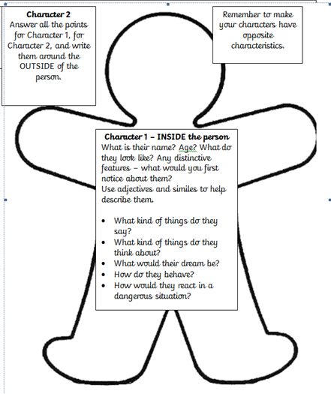
- Write your 10 words in coloured pens or pencils. Make each letter a different colour. | You may have read or watched about Captain Tom Moore, who is 99 years old and has raised lots of money for the NHS. It’s his 100th birthday on the 30th April. How about making him a birthday card and writing a note inside it, congratulating him and thanking him for raising all that money. You would need to post the card to:  Captain Tom Moore  C/O Post Office Limited  67 Bedford Road  Marston Moretaine  MK43 0LA  Bedfordshire, England
Learning Project - to be done throughout the week
The project this week aims to provide opportunities for your child to learn more about the area in which they live. Learning may focus on your local area, famous people or key landmarks.
Promoting Your Local Area-​ Tell your child that a visitor from another country is coming to stay in the city for a week. They really need to impress them by showing them the most interesting places in their local area. Where would they take them each day? Plan the itinerary for each day detailing the transport that will be taken to each location, how long will be spent there, what will be eaten and any activities that may take place.
Where in the World? - ​Show your child how to use Google Earth or Google Maps to look at the geographical features of Cornwall, Aberystwyth (Wales) and Perth (Australia). How are these places the same? How are these places different? What impacts the similarities and differences? After, they can then choose three different places and do the same thing. Do they notice any patterns?
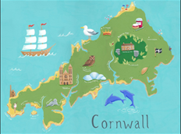
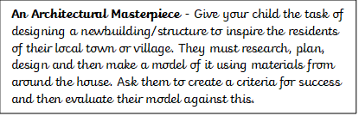
Places of Worship – There are many places to worship within St Austell. Can your child find out about 5 of these, and put them in order of when they were built? Do they notice a difference in the buildings built many years ago and the design of the more modern buildings? This research could be done using Google, you could go on a walk around the local area as part of your daily exercise.

