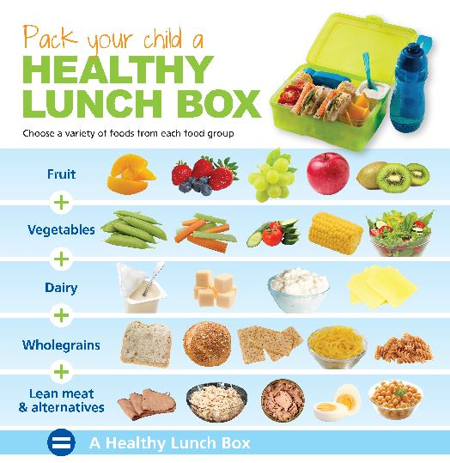
Food for thought!

Too much or too little? Are you packing your child off with the ‘right stuff’? We hope these hints and helpful guides will give parents and carers a little more information about what every child needs to fuel their day the right way!

What to include in lunch boxes:

Fruits and vegetables
How much? At least 1 fruit and 1 vegetable in each lunchbox
Examples: Fresh fruit, tinned fruits (in juice not syrup), dried fruits, salad items & vegetables. You could include vegetable crudites for dipping or add veggies to salads, pasta or rice dishes
Why? Fruit and vegetables are a good source of vitamins, minerals, fibre and anti-oxidants
Tips: Aim for a variety of colours. Not only will it make the lunchbox look more appetising but it also provides a variety of different vitamins and minerals.

Potatoes, bread, rice, pasta and other starchy foods
How much? Include at least 1 portion
Examples; Sandwiches, pitta bread, wraps, pasta salad, potato salad, sweet potato wedges, rice dishes, cous cous, bread sticks, crackers, oat cakes, rice cakes
Why? These foods will provide energy, fuel for vital tissues and organs including the brain, fibre, B vitamins and other minerals.
Tips: Try to include some wholegrain varieties from this food group each week such as brown, wholemeal, granary or 50/50 bread, wholewheat pasta or brown rice.

Dairy and alternatives
How much? Include at least 1 portion
Examples: Carton of milk, cheese, yoghurts, custard, rice pudding, milk or yoghurt based smoothies, soya, oat and nut based milks
Why? These foods provide calcium, B vitamins and protein
Tips: If your child is over 2yrs and growing well opt for semi-skimmed milk and low fat yoghurts and cheeses.

Beans, pulses, fish, eggs, meat and other proteins
How much? Include at least 1 portion in every lunchbox
Examples: Chicken, turkey, pork, beef, lamb, beans, fish, shellfish, lentils, chickpeas, pulses, soya products such as tofu, quorn, hummus
Why? These foods provide protein, iron and zinc.
Tips: Try to include at least one portion of fish each week. Oily fish such as fresh, tinned or frozen salmon, sardines, pilchards, mackerel, herring, and fresh tuna may be beneficial for children’s cognitive development. Try a salmon or mackerel pate as a dip or sandwich filler.

Drinks
How much? Include a healthy drink daily
Examples: Milk and water are the only tooth friendly drinks for children and are the best options for your child’s lunchbox.
Tip: There’s no need to spend money on exotic or colourful looking drinks. Tap water is free and one of the healthiest drinks you can offer your child. Fill a reusable bottle with fresh tap water.

https://www.nhs.uk/change4life/recipes/healthier-lunchboxes

This website has heaps of links to some recipes for fantastic lunch box ideas if you are finding that you are stuck with the same old ideas week in week out!

https://www.bbcgoodfood.com/howto/guide/healthy-lunches-for-kids

This website includes helpful hints for picky eaters and great information about ‘quantities’ and how much food a child really needs!

Guideline Daily Amounts for children aged 5-10
Energy | 1,800kcal
Protein | 24g
Carbohydrates | 220g
Sugar | 85g
Fat | 70g
Saturates | 20g
Fibre | 15g
Salt | 4g

