**What knowledge will the children gain throughout their time in Bishop Bronescombe School? What key vocabulary will they explore and better understand?**

Through their work in Geography during their time at Bishop Bronescombe, the children begin by exploring their local area, focusing on increasing scales beginning with the area of their school grounds. They then move onto comparing their home area with other regions both in the United Kingdom and the rest of the world. They learn how to draw and interpret maps, understand map symbols and they develop the skills of investigation and analysis. Bishop Bronescombe strives for learning that carries children through the rest of their lives and through their learning and understanding of Human Geography, children gain an appreciation and respect for alternative cultures and ways of life. Geography also allows them to learn about the physical world: how the world is formed and physical features can support human life. Not only this, it enables them to recognise the importance of sustainable development, and encourage their consideration for their future lives and future world. Within their Geography learning at Bishop Bronescombe, there are key vocabulary terms that they will become confident with using and exploring both within and beyond their Geography lessons.

|  |  |  |  |  |
| --- | --- | --- | --- | --- |
| Map | Symbol | Key | Weather/ Seasons | Climate |
| City | Development | Change | Vegetation | Diversity |
| Beach | Coasts | The Water Cycle | Biome | Tourism |
| Region | Country | Town | Village | Environment |

These vocabulary terms will be taught and embedded throughout our pupils’ journey through Primary school.

**What do we want our pupils to know by the time they leave KS2?**

It is our intent for Geography to inspire our pupils with a curiosity and fascination about the world around them that will ignite their natural inquisitive nature as they move through their lives. By the time the children leave Key Stage 2, we have the aim for the children to gain a sense of awareness and understanding of the world around them; from the area they live, to an understanding of the relationship between physical and human processes within our environment and how they change over time. As well as this, we want them to develop an understanding of the cultural diversity of our world and the benefits of embracing diversity into their lives. The children should be able to appreciate the environment in which they live and use this appreciation to better research the questions that our world generates.

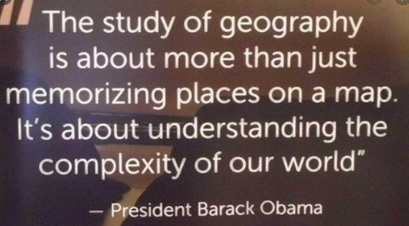

**How do we make sure pupils know more and remember more?**

To ensure that the children know and remember more of their Geography knowledge, each lesson will begin with informal questioning as a class that aims to recall key information from their previous lesson. This will also be encouraged through the use of teacher-led recall of previous knowledge, as well as the children being provided with opportunities to develop and independently extend their understanding through continuous provision opportunities in Key Stage 1, and research or outdoor learning opportunities in Key Stage 2, linking with other subjects where possible.

**Geography**

**What do we want our pupils to experience?**

The purpose of our Geography curriculum is to encourage the children to develop a love of and a natural, passionate sense of enquiry about their environment. We want the children to experience a drive for increasing their own knowledge base through a combination of theory, practical and explorative learning opportunities, which will provide them with a sense of understanding about their world, and their place within the world.

**How will a fulfilling Geography curriculum be implemented at Bishop Bronescombe?**

At Bishop Bronescombe, Geography will be implemented through teaching that provides children with the foundations of the theory of our world and its development, as well as opportunities for independent research and discovery. In KS1, the learning will be conducted through a predominantly skills-based curriculum, focusing on map exploration and the children’s independent interests, linking this to broad topic areas where possible. In KS2, the teaching will explore the subject through questioning that will encourage the children to think more deeply about the world in which they live. They will also be given opportunities through research and outdoor, collaborative learning to further increase their knowledge base and fascination of their world. The subject will be taught through a combination of explicit teaching, research and open-ended investigations as well as cross-curricular learning alongside other subjects, which will allow the children to recall and consolidate key areas of their learning.