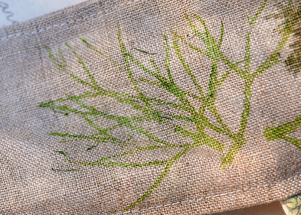
Monday: Natural Resources
Hapazome- Leaf Printing
Hapa Zome is a Japanese word meaning ‘leaf dye’ and is given to the process of transferring the natural pigments from leaves and flowers onto fabric or paper to create a botanical image. The activity is incredibly relaxing and very simple, making it of interest to people of all ages and abilities.
Step One
Choose your selection of leaves or flowers. The best floral to use are those with bright colours and juicy petals or leaves.
Next, lay a piece of fabric or cloth flat onto a surface and arrange your selection of plants into a design of your choice. Once you are happy with the design, cover it with paper or another piece of thin fabric.
Step Two
Using a hammer or a rounded pebble, bash where the plants lay. Keep hammering across your design in a methodical way to produce the best results.
Once you’re finished, peel off the top layer. Your leaves and flowers will resemble a bit of a mushy mess but don’t worry – once you peel off the foliage your design print will be revealed. You can keep adding new leaves or petals to your image by repeating the process.
Step Three
When you’re happy with your image you can then iron the design. The steam will help set the colours and prevent them from fading.
You can then use your fabric or paper any way you choose, either kept intact as artwork or divided to use in other craft projects.
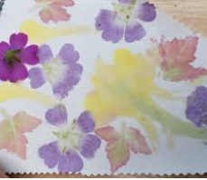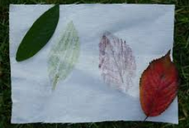
Tuesday Land Art-Based on the work by David Goldsworthy
Land art focus-Texture

Based on David Goldsworthy’s Land Art, pupils are to create their own piece of art, with the focus on Texture.

- Watch the video: https://www.youtube.com/watch?v=gdcmuiNj_mM

- Show images of art by Andy Goldsworthy to see some good examples.

- Collect a variety of items from nature. Think about the composition when collecting items, focusing on the texture you create.

- Create art work. Take time to make it really accurate. What could be improved?

- Remember to take a photo of it when it is complete.
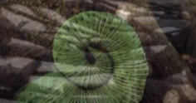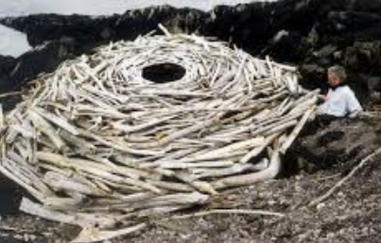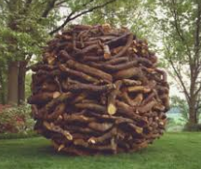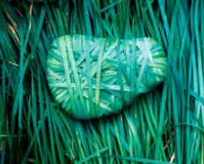
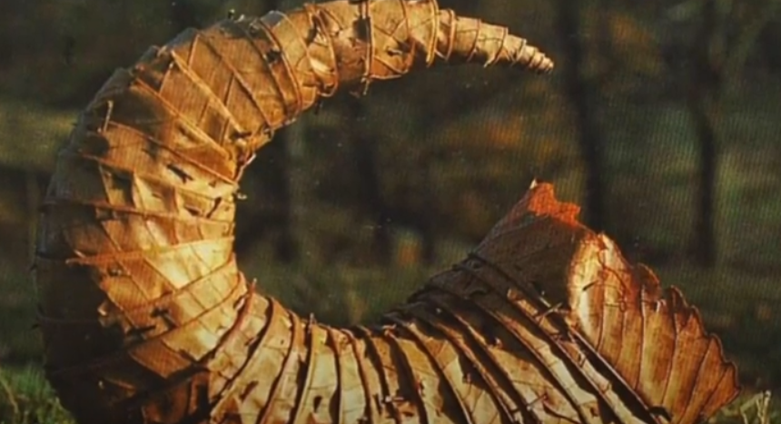

Wednesday: Drawing from Nature
Typography- Natural and Man-made
- Talk about some of the typefaces we are familiar with, and how easy it is using computers to experiment with different fonts for different purposes.

- Introduce the idea that someone somewhere had designed the typefaces, just like someone designs the cups and plates and cars we use, and that this is the art of typography.

- Get the children to begin with some observational drawing, not only to give them a starting point for their typography, but also to reinforce the relationship of drawing to design.

- Present the children with three very different starting points in terms of subject matter: 1) pieces of metal, buts, bolts, screws etc, 2) twigs and 3) grasses.

- Ask the children to study the subject matter and search out shapes which reminded them of letters, or even pick the subject matter up, and start to make letters out of the elements.

- Remind the children of the difference between upper and lower case letters. Give out sheets of paper for them to work on – uppercase letters were drawn on A4 sheets, lowercase letters on A5 sheets.

- Ask the children to think of their letters as having substance, i.e. being chunky – not just lines on a page.

- Encourage them to draw their letters to fill the sheets- careful, slow, looking and mark making. Children to make rough sketches in pencil before going over their lines in pen.

- Take photos of finished piece.
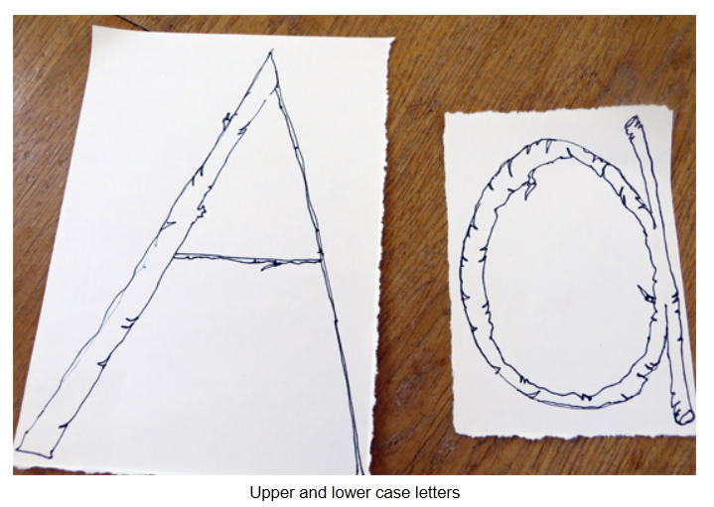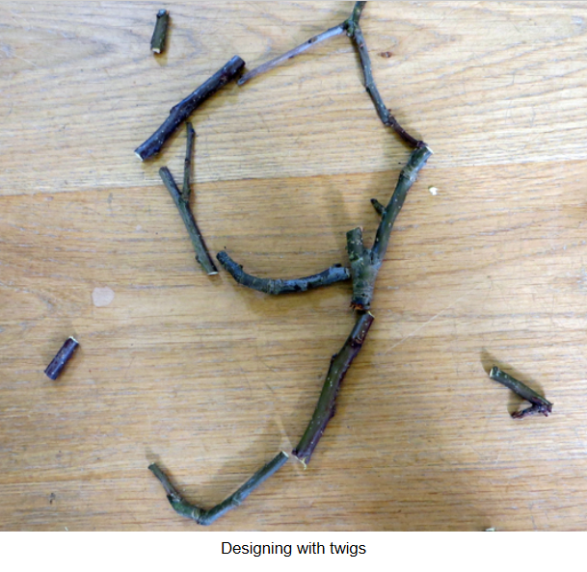
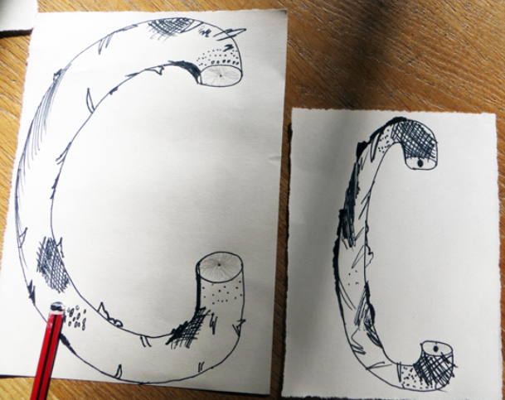
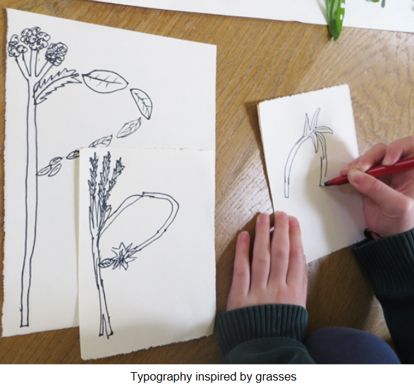
Thursday: 3D Art
‘Where the Wild Things Are’ Animal Sculptures

You Will Need:
- Plastic bags (or bin bags or newspaper)
- Sellotape
- Images from “Where the Wild Things Are” by Maurice Sendak

Outcome:
- The opportunity to explore a key sculptural concepts of balance.
- The opportunity to experience how materials can be manipulated and transformed.
- Experience in “design through making”.
- The creation of an “armature”, ready for the next session.

To Begin:
Look at the animals from “Where the Wild Things Are” story and discuss around the kinds of shapes and positions of the creatures. Which shapes helped give the creatures their character or personality? Talk about the problems of making a creature which stands on just two legs – would it fall over? Suggest making creatures on four legs, or making creatures, which were sitting down, or using another element such as a tail to help the sculpture balance
A note about carrier bags
Use old carrier bags to make our inner structure. If you don’t like the idea behind using plastic, you can use newspaper instead, but plastic has two distinct benefits. 1) It is easier for little hands to model, and 2) it does not go soggy and lose form during the paper mache stage which follows. If you wish to recycle the plastic afterwards (and you can bear to destroy the sculpture!) you can easily cut the paper mache away and pull the bags out to recycle them.
However if this bothers you, you will still get good results with newspaper.
Step 1
Take one carrier bag and pull it into a thin shape in your hands. To make a leg for your wild thing, fold this thin shape into three (to make it shorter and ticker). Use sellotape to bind the bag in place.
Step 2
Do the same with another bag and then tape it to a third bag to make two legs and a pelvis (here pictured on its side).
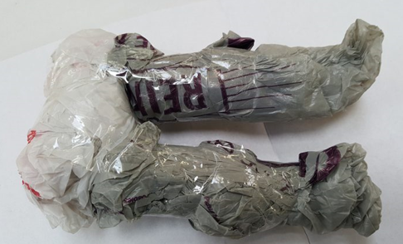
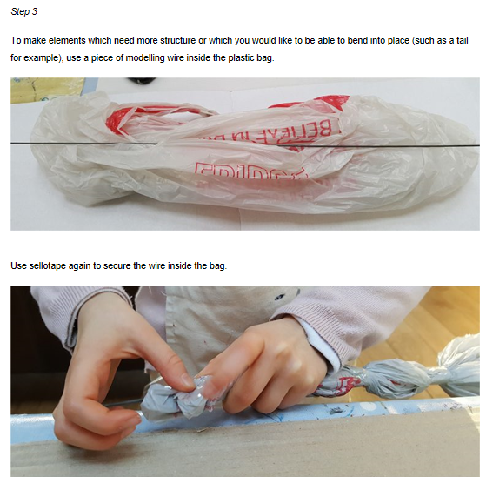

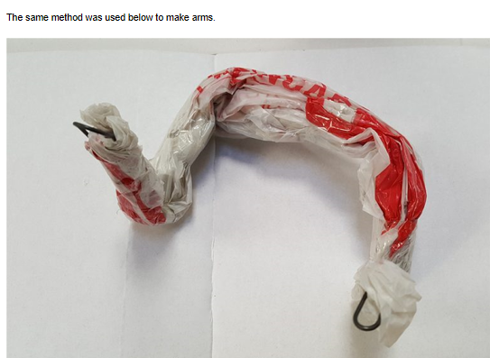
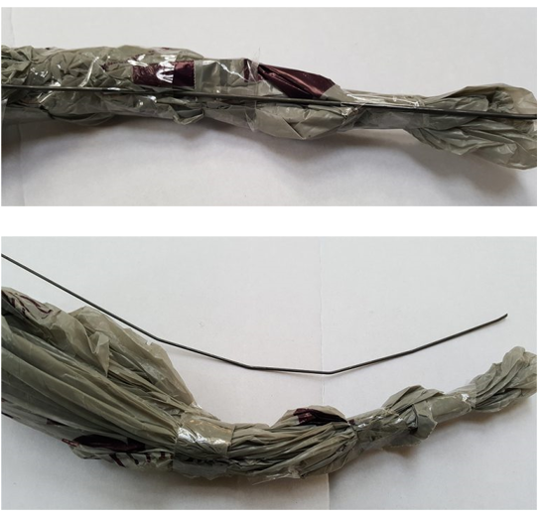
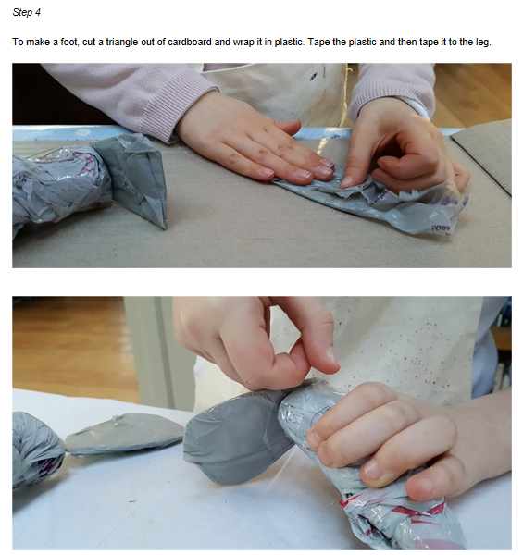
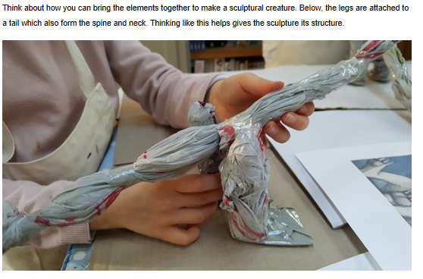
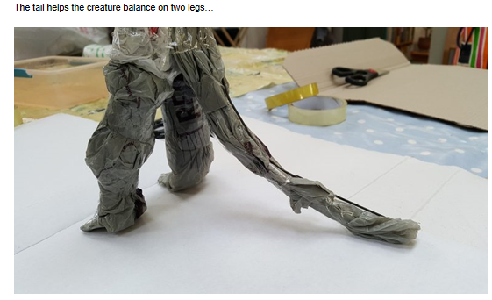
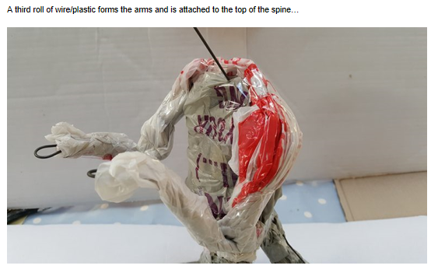
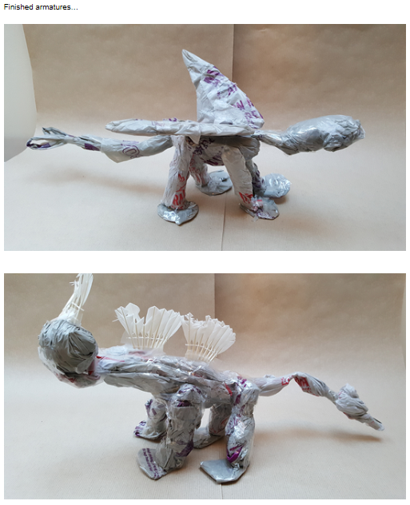

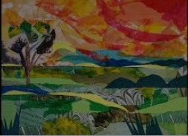
Friday: Collage
Create a backdrop for your animal sculpture you made yesterday
Watch https://www.youtube.com/watch?v=0hG-mgQPess for ideas on how to create a collage.
To create a paper collage you will need:
1. A sheet of paper
2. Paint and/or coloring pencils (optional)
3. Pencils
4. Glue
5. Paintbrush
6. Coloured paper and magazines
8. Scissors (optional)
Step 1: Pick any picture or image of a natural world landscape that you like your creature to live in and base it off of that. It could be anything (a forest, a rainforest, a river bank, the beach etc)
Step 2: Draw out a rough sketch of sections to plot the landscape i.e. draw where you’d like the trees, rocks etc.
Step 3: Now that your picture is now on your canvas, use paint, colouring pencils, or simply write the name of the colours in their desired areas. This makes it easier to arrange the colours with the paper later on.
Step 4: You now need to get some paper (preferably magazine paper). Find pages out of magazines that match the colours you are using and tear them up into small pieces. (This is where the scissors are optional depending on how you want your collage to come out. The scissors may make a cleaner cut but you may prefer the rough look tearing the paper by hand provides.)
Step 5: Using a paintbrush, lightly spread layers of glue on your canvas. This is the only way your pieces of paper will stick to your canvas.
